Motherboard

Alternatively referred to as the mb, mainboard, mobo, mobd, backplane board, base board, main circuit board, planar board, system board, or a logic board on Apple computers. The motherboard is a printed circuit board that is the foundation of a computer, located on the back side or at the bottom of the computer case. It allocates power to the CPU, RAM, and all other computer hardware components. Most importantly, the motherboard allows hardware components to communicate with one another.

The first motherboard is considered to be one used in the IBM Personal Computer, released in 1981. At the time, IBM referred to it as a "planar" instead of a motherboard. The IBM Personal Computer and the motherboard inside it would set the standard for IBM-compatible computer hardware going forward.

Below is a picture of the ASUS P5AD2-E motherboard with names of each major component of the motherboard. Clicking on the image below gives you a larger more detailed version of the picture below.

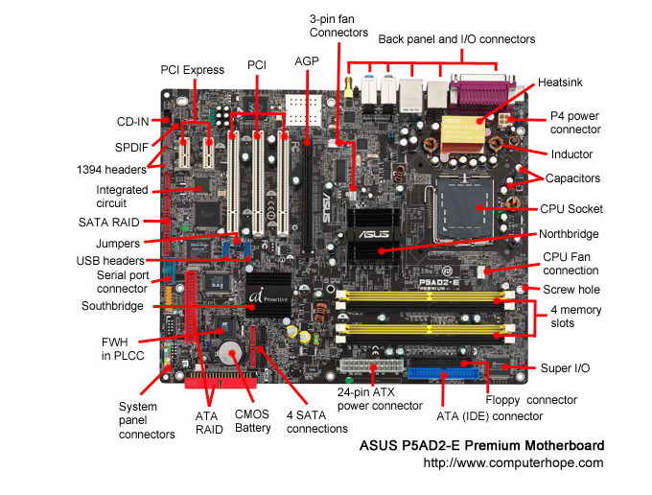

Q:

**Who invented the first motherboard?**

A:

**Quick Answer**

**The IBM personal computer contained the first motherboard, which was referred to as the “breadboard” and was released in 1981.** The breadboard provided a platform for the computers RAM and CPU and also had ports for a keyboard, mouse and cassette tape.

[Continue Reading](https://www.reference.com/history/invented-first-motherboard-eb3ca3f7c43cb92a)

**Keep Learning**

**[What is a computer made of?](https://www.reference.com/history/computer-made-fef1d84370dc4797)**

**[What is computer addiction?](https://www.reference.com/history/computer-addiction-3cbbd962918cb0b1)**

**[Who invented software?](https://www.reference.com/history/invented-software-8925645cbbcda286)**

**Full Answer**

When compared to modern motherboards, the planar provided the function of supplying a circuit board with expansion slots for other hardware devices. The original breadboard also provided a built in audio capability as well, while also having a system named a bus to manage the flow of information. The original breadboard provided a built-in audio capability as well, while also possessing an information transportation system, appropriately named a "bus," to manage the flow of information.

[Learn more about Computer Histo](https://www.reference.com/history/explore/computer-history)

### Full Answer

Modern computers can be very small, and they appear in a variety of modern products. Small computers can be found in cellular phones, modern cameras and automobiles, where their incredibly fast mathematical abilities help make the lives of humans easier.

Primitive computers have been around for thousands of years, although they look nothing like modern computers. Completely bereft of moving parts, the first calculating devices were called counting boards. These boards featured grooved lines and beads that could be placed in the grooves. Such calculators were helpful for keeping track of large numbers; but soon, better tools, such as the abacus, were invented. An abacus is a wooden frame with wooden balls that slide back and forth along narrow rods. True calculating devices were invented in the early 19th century; but while these elaborate devices were more helpful than counting boards and similar tools, they were very expensive to constr

A **motherboard** is the central printed circuit board (PCB) in computers that holds many of the crucial components of the system, while providing connectors for other peripherals. The motherboard is sometimes alternatively known as the mainboard, system board, or, on Apple computers, the logic board. It is also sometimes casually shortened to mobo.

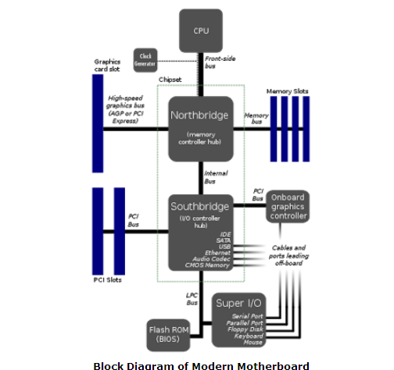

The block diagram of the motherboard suggests that a motherboard is the most important part of a computer that allows all the parts of our computer to receive power and communicate with one another.

## History of Motherboards

• Before generation of Microprocessors i.e. in 1st, 2nd and 3rd generation computers, the computer was usually built in a card-cage case or mainframe with components connected by a backplane consisting of a set of slots themselves connected with wires; in very old designs the wires were discrete connections between card connector pins.

• But printed circuit boards soon became the standard practice in the late 1970s. The Central Processing Unit, memory and peripherals were housed on individual printed circuit boards which plugged into the **backplane**. (A backplane is a circuit board that connects several connectors in parallel to each other, so that each pin of each connector is linked to the same relative pin of all the other connectors, forming a computer bus.)

• During the late 1980s and 1990s, it was found that increasing the number of peripheral functions on the PCB was very economical. Hence, single Integrated Circuits (ICs), capable of supporting low-speed peripherals like serial ports, mouse, keyboards, etc., were included on the motherboards. By the late 1990s, motherboards began to have full range of audio, video, storage and networking functions on them. Higher end systems for 3D gaming and graphic cards were also included later.

• Micronics, Mylex, AMI, DTK, Orchid Technology, Elitegroup, etc. were few companies that were early pioneers in the field of motherboard manufacturing but, companies like Apple and IBM soon took over.

• Companies like IBM and Apple offered high end, sophisticated motherboards that included upgraded features and superior performance over prevailing motherboards.

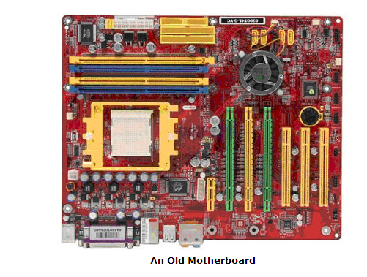

• Today, motherboards typically boast a wide variety of built-in features, and they directly affect a computer's capabilities and potential for upgrades.

• Today Intel and Asus are the two leading companies in the field of motherboard manufacturing.

**Timeline of Motherboard & its Industry:**

**1975**: Introduction of Apple I, a device that consisted a motherboard, a keyboard and a display.

**1987**: Elitegroup Computer Systems Co. Ltd was established in Taiwan and became the largest supplier of motherboards in the world.

**1989**: AsusTek, one of Taiwan’s top 5 company, started manufacturing graphic cards.

**1993**: First International Computer Inc. becomes the largest motherboard manufacturer in the world.

**1997**: Intel Corp. plans to add to its monopoly in microprocessor by manufacturing motherboards.

**2000**: ATI Technologies Inc. announces graphic cards technology, an advancement, in computer graphics.

**2007**: AsusTek becomes the world’s largest maker of computer motherboards.

**Motherboard Components**

• A typical desktop computer has its microprocessor, main memory, and other essential components connected to the motherboard. Other components such as external storage, controllers for video display and sound, and peripheral devices may be attached to the motherboard as plug-in cards or via cables, although in modern computers it is increasingly common to integrate some of these peripherals into the motherboard itself.

• **Few things that a motherboard nowadays include are:**

* **sockets** (or slots) in which one or more microprocessors may be installed.
* **slots** into which the system's main memory is to be installed (typically in the form of DIMM modules containing DRAM chips).
* a **chipset** which forms an interface between the CPU's front-side bus, main memory, and peripheral buses.
* **non-volatile memory chips** (usually Flash ROM in modern motherboards) containing the system's firmware or BIOS.
* a **clock generator** which produces the system clock signal to synchronize the various components.
* **slots for expansion cards** (these interface to the system via the buses supported by the chipset).
* **power connectors**, which receive electrical power from the computer power supply and distribute it to the CPU, chipset, main memory, and expansion cards.

• Additionally, nearly all motherboards include logic and connectors to support commonly used input devices, such as PS/2 connectors for a mouse and keyboard. Occasionally video interface hardware is also integrated into the motherboard. Additional peripherals such as disk controllers and serial ports are provided as expansion cards.

• Given the high thermal design power of high-speed computer CPUs and components, modern motherboards nearly always include heat sinks and mounting points for fans to dissipate excess heat.

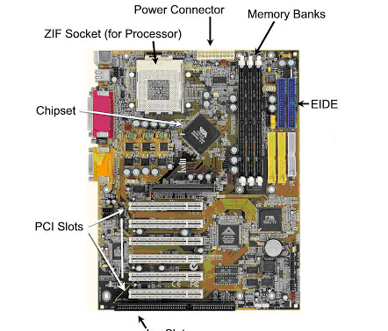

**CPU Sockets**

• A CPU socket or slot is an electrical component that attaches to a printed circuit board (PCB) and is designed to house a CPU (also called a microprocessor).

• It is a special type of integrated circuit socket designed for very high pin counts. A CPU socket provides many functions, including a physical structure to support the CPU, support for a heat sink, facilitating replacement (as well as reducing cost), and most importantly, forming an electrical interface both with the CPU and the PCB.

• CPU sockets can most often be found in most desktop and server computers (laptops typically use surface mount CPUs), particularly those based on the Intel x86 architecture on the motherboard. A CPU socket type and motherboard chipset must support the CPU series and speed.

**Integrated Peripherals**

• It is possible to include support for many peripherals on the motherboard. By combining many functions on one PCB, the physical size and total cost of the system may be reduced; highly integrated motherboards are thus especially popular in small form factor and budget computers.

**Peripheral Card Slots**

• A standard ATX motherboard will typically have one PCI-E 16x connection for a graphics card, two conventional PCI slots for various expansion cards, and one PCI-E 1x. A standard EATX motherboard will have one PCI-E 16x connection for a graphics card, and a varying number of PCI and PCI-E 1x slots. It can sometimes also have a PCI-E 4x slot.

• Some motherboards have two PCI-E 16x slots, to allow more than 2 monitors without special hardware, or use a special graphics technology called SLI (for Nvidia) and Crossfire (for ATI). These allow 2 graphics cards to be linked together, to allow better performance in intensive graphical computing tasks, such as gaming and video editing.

• Virtually all motherboards come with at least four USB ports on the rear, with at least 2 connections on the board internally for wiring additional front ports that may be built into the computer's case.

• Ethernet is also included. Ethernet is a standard networking cable for connecting the computer to a network or a modem.

• A sound chip is always included on the motherboard, to allow sound output without the need for any extra components. This allows computers to be far more multimedia-based than before. Some motherboards contain video outputs on the back panel for integrated graphics solutions (either embedded in the motherboard, or combined with the microprocessor, such as the Intel HD Graphics).

**Computer Cooling**

• Motherboards are generally air cooled with heat sinks often mounted on larger chips, such as the Northbridge, in modern motherboards. If the motherboard is not cooled properly, it can cause the computer to crash.

• Passive cooling, or a single fan mounted on the power supply, was sufficient for many desktop computer CPUs until the late 1990s; since then, most have required CPU fans mounted on their heat sinks, due to rising clock speeds and power consumption. Most motherboards have connectors for additional case fans as well.

• Newer motherboards have integrated temperature sensors to detect motherboard and CPU temperatures, and controllable fan connectors which the BIOS or operating system can use to regulate fan speed. Some computers (which typically have high-performance microprocessors, large amounts of RAM, and high-performance video cards) use a water-cooling system instead of many fans.

**Bus & Bus Speed**

• A bus is simply a circuit that connects one part of the motherboard to another. The more data a bus can handle at one time, the faster it allows information to travel. The speed of the bus, measured in megahertz (MHz), refers to how much data can move across the bus simultaneously.

• Bus speed usually refers to the speed of the front side bus (FSB), which connects the CPU to the northbridge. FSB speeds can range from 66 MHz to over 800 MHz. Since the CPU reaches the memory controller though the northbridge, FSB speed can dramatically affect a computer's performance.

**Memory**

• The speed of the chipset and busses controls how quickly it can communicate with other parts of the computer. The speed of the RAM connection directly controls how fast the computer can access instructions and data, and therefore has a big effect on system performance. A fast processor with slow RAM is going nowhere.

• The amount of memory available also controls how much data the computer can have readily available. RAM makes up the bulk of a computer's memory. The general rule of thumb is the more RAM the computer has, the better.

• Much of the memory available today is dual data rate (DDR) memory. This means that the memory can transmit data twice per cycle instead of once, which makes the memory faster. Also, most motherboards have space for multiple memory chips, and on newer motherboards, they often connect to the northbridge via a dual bus instead of a single bus. This further reduces the amount of time it takes for the processor to get information from the memory.

• A motherboard's memory slots directly affect what kind and how much memory is supported. Just like other components, the memory plugs into the slot via a series of pins. The memory module must have the right number of pins to fit into the slot on the motherboard.

**Form factor**

• Motherboards are produced in a variety of sizes and shapes called computer form factor, some of which are specific to individual computer manufacturers.

• The current desktop PC form factor of choice is ATX. A case's motherboard and PSU form factor must all match, though some smaller form factor motherboards of the same family will fit larger cases. For example, an ATX case will usually accommodate a microATX motherboard.

• Laptop computers generally use highly integrated, miniaturized and customized motherboards. This is one of the reasons that laptop computers are difficult to upgrade and expensive to repair. Often the failure of one laptop component requires the replacement of the entire motherboard, which is usually more expensive than a desktop motherboard due to the large number of integrated components.

**Bootstrapping using the BIOS**

• Motherboards contain some non-volatile memory to initialize the system and load an [**operating system**](http://jabroo.blogspot.com/2011/08/operating-systems-its-types.html) from some external peripheral device.

• Most modern motherboard designs use a BIOS, stored in an EEPROM chip soldered or socketed to the motherboard, to bootstrap an operating system. When power is first applied to the motherboard, the BIOS firmware tests and configures memory, circuitry, and peripherals. This Power-On Self Test (POST) may include testing some of the following devices:

1. video adapter
2. cards inserted into slots, such as conventional PCI
3. thermistors, voltages, and fan speeds for hardware monitoring
4. CMOS used to store BIOS setup configuration
5. keyboard and mouse
6. network controller
7. optical drives: CD-ROM or DVD-ROM
8. SCSI hard drive
9. IDE, EIDE, or SATA hard disk
10. security devices, such as a fingerprint reader or the state of a latch switch to detect intrusion
11. USB devices, such as a memory storage device

**Conclusion**

• Motherboard is the most important part of computer without which it is very difficult to think about computers. Motherboards have revolutionized the way computers are designed and their sizes have become smaller too. Just a single motherboard holds millions of transistors now and research and development is still on their improvement.

# Bus

When referring to a computer, the **bus** also known as the **address bus, data bus,** or **local bus** is a data connection between two or more devices connected to the computer. For example, a bus enables a computer [processor](http://www.computerhope.com/jargon/c/cpu.htm) to communicate with the [memory](http://www.computerhope.com/jargon/r/ram.htm) or a [video card](http://www.computerhope.com/jargon/v/videadap.htm) to communicate with the memory.

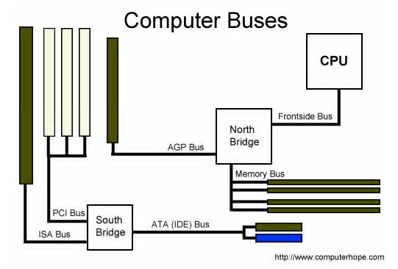

he bus contains multiple wires (signal lines) that contain addressing information that describes the memory location of where the data is being sent or where it is being retrieved. Each wire in the bus carries a single bit of information, which means the more wires a bus has the more information it can address. For example, a computer with a 32-bit address bus can address 4GB of memory, and a computer with a 36-bit bus can address 64GB of memory.

A bus is capable of being a [parallel](http://www.computerhope.com/jargon/p/parallel.htm) or [serial](http://www.computerhope.com/jargon/s/serial.htm) bus and today all computers utilize two bus types, an **internal bus** or local bus and an **external bus**, also called the **expansion bus**. An internal bus enables communication between internal components such as a [video card](http://www.computerhope.com/help/video.htm) and [memory](http://www.computerhope.com/jargon/m/memory.htm). An external bus is capable of communicating with external components such as a USB or SCSI device.

A computer or device's **bus speed** is listed as a [MHz](http://www.computerhope.com/jargon/m/mhz.htm), e.g. 100MHz FSB. The [throughput](http://www.computerhope.com/jargon/t/throughp.htm) of a bus is measured in [bits per second](http://www.computerhope.com/jargon/b/bps.htm) or [megabytes per second](http://www.computerhope.com/jargon/m/mbps.htm).

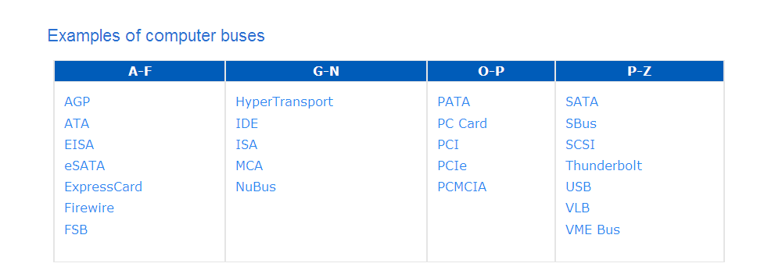

# AGP

Short for **Accelerated Graphics Port**, **AGP** is an advanced port designed for Video cards and 3D accelerators. Designed by [Intel](http://www.computerhope.com/comp/intel.htm) and introduced in August of [1997](http://www.computerhope.com/history/1997.htm), AGP introduces a dedicated point-to-point channel that allows the graphics controller direct access to the system [memory](http://www.computerhope.com/jargon/m/memory.htm). Below is an illustration of what the AGP slot may look like on your [motherboard](http://www.computerhope.com/jargon/m/mothboar.htm).

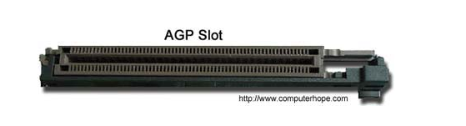

The AGP channel is [32-bits](http://www.computerhope.com/jargon/num/32bit.htm) wide and runs at 66 [MHz](http://www.computerhope.com/jargon/m/mhz.htm), which is a total bandwidth of 266 MBps and much greater than the PCI bandwidth of up to 133 [MBps](http://www.computerhope.com/jargon/m/mbps.htm). AGP also supports two optional faster modes, with a throughput of 533 MBps and 1.07 GBps. It also allows 3-D textures to be stored in main memory rather than video memory.

AGP is available in three different versions, the original AGP version mentioned above, **AGP 2.0** that was introduced in May of [1998](http://www.computerhope.com/history/1998.htm), and **AGP 3.0** (**AGP 8x**) that was introduced in November of [2000](http://www.computerhope.com/history/2000.htm). AGP 2.0 added 4x signaling and was capable of operating at 1.5V and AGP 3.0 was capable of double the transfer speeds.

**Most popular computer bus**

Today, many of the buses listed above are no longer used or are not as common. Below is a listing of the most buses and how they are used with a computer.

* [**eSATA**](http://www.computerhope.com/jargon/s/sata.htm) **and** [**SATA**](http://www.computerhope.com/jargon/s/sata.htm) - Computer [hard drives](http://www.computerhope.com/jargon/h/harddriv.htm) and [disc drives](http://www.computerhope.com/jargon/o/optidisc.htm).
* [**PCIe**](http://www.computerhope.com/jargon/p/pciexpre.htm) - Computer [expansion cards](http://www.computerhope.com/jargon/e/expacard.htm) and [video cards](http://www.computerhope.com/jargon/v/videadap.htm).
* [**USB**](http://www.computerhope.com/jargon/u/usb.htm) - Computer [peripherals](http://www.computerhope.com/jargon/p/peripher.htm).

**Related pages**

* [How do I determine my computer bus speed?](http://www.computerhope.com/issues/ch001415.htm)
* [Computer bus help and support.](http://www.computerhope.com/help/bus.htm)
* [Computer motherboard help and support.](http://www.computerhope.com/help/mb.htm)

# Bus

*This article includes information originating from* [*Wikipedia*](http://www.wikipedia.org).

In [computer architecture](http://gunkies.org/w/index.php?title=Computer_architecture&action=edit&redlink=1), a **bus** is a subsystem that transfers data or power between computer components inside a [computer](http://gunkies.org/w/index.php?title=Computer&action=edit&redlink=1) or between computers and typically is controlled by [device driver](http://gunkies.org/w/index.php?title=Device_driver&action=edit&redlink=1) software. Unlike a [point-to-point connection](http://gunkies.org/w/index.php?title=Point-to-point_link&action=edit&redlink=1), a bus can logically connect several [peripherals](http://gunkies.org/w/index.php?title=Peripheral&action=edit&redlink=1) over the same set of wires. Each bus defines its set of [connectors](http://gunkies.org/w/index.php?title=Connector&action=edit&redlink=1) to physically plug devices, cards or cables together.

Early computer buses were literally parallel [electrical buses](http://gunkies.org/w/index.php?title=Electrical_bus&action=edit&redlink=1) with multiple connections, but the term is now used for any physical arrangement that provides the same logical functionality as a parallel electrical bus. Modern computer buses can use both parallel and bit-serial connections, and can be wired in either a [multidrop](http://gunkies.org/w/index.php?title=Multidrop&action=edit&redlink=1) (electrical parallel) or [daisy chain](http://gunkies.org/w/index.php?title=Daisy_chain&action=edit&redlink=1) topology, or connected by switched hubs, as in the case of [USB](http://gunkies.org/w/index.php?title=Universal_Serial_Bus&action=edit&redlink=1).

## Contents

**First generation**

Early [computer](http://gunkies.org/w/index.php?title=Computer&action=edit&redlink=1) buses were bundles of wire that attached [memory](http://gunkies.org/w/index.php?title=Computer_storage&action=edit&redlink=1) and peripherals. They were named after [electrical buses](http://gunkies.org/w/index.php?title=Electrical_bus&action=edit&redlink=1), or busbars. Almost always, there was one bus for memory, and another for peripherals, and these were accessed by separate instructions, with completely different timings and protocols.

One of the first complications was the use of [interrupts](http://gunkies.org/w/index.php?title=Interrupt&action=edit&redlink=1). Early computers performed [I/O](http://gunkies.org/w/index.php?title=Input/output&action=edit&redlink=1) by waiting in a loop for the peripheral to become ready. This was a waste of time for programs that had other tasks to do. Also, if the program attempted to perform those other tasks, it might take too long for the program to check again, resulting in lost data. Engineers thus arranged for the peripherals to interrupt the CPU. The interrupts had to be prioritized, because the CPU can only execute code for one peripheral at a time, and some devices are more time-critical than others.

Some time after this, some computers began to share memory between several CPUs. On these computers, access to the bus had to be prioritized, as well.

The classic, simple way to prioritize interrupts or bus access was with a [daisy chain](http://gunkies.org/w/index.php?title=Daisy_chain&action=edit&redlink=1).

[DEC](http://gunkies.org/wiki/Digital_Equipment_Corporation) noted that having two buses seemed wasteful and expensive for small, mass-produced computers, and mapped peripherals into the memory bus, so that the devices appeared to be memory locations. At the time, this was a very daring design. Cynics predicted failure.

Early [microcomputer](http://gunkies.org/w/index.php?title=Microcomputer&action=edit&redlink=1) bus systems were essentially a passive [backplane](http://gunkies.org/w/index.php?title=Backplane&action=edit&redlink=1) connected to the pins of the [CPU](http://gunkies.org/w/index.php?title=Central_processing_unit&action=edit&redlink=1). Memory and other devices would be added to the bus using the same address and data pins as the CPU itself used, connected in parallel. In some instances, such as the [IBM PC](http://gunkies.org/wiki/IBM_PC), instructions still generated signals at the CPU that could be used to implement a true I/O bus.

In many microcontrollers and [embedded systems](http://gunkies.org/w/index.php?title=Embedded_systems&action=edit&redlink=1), an I/O bus still does not exist. Communication is controlled by the [CPU](http://gunkies.org/w/index.php?title=Central_processing_unit&action=edit&redlink=1), which reads and writes data from the devices as if they are blocks of memory (in most cases), all timed by a central clock controlling the speed of the CPU. Devices ask for service by signalling on other CPU pins, typically using some form of [interrupt](http://gunkies.org/w/index.php?title=Interrupt&action=edit&redlink=1).

For instance, a [disk drive](http://gunkies.org/w/index.php?title=Disk_drive&action=edit&redlink=1) controller would signal the CPU that new data was ready to be read, at which point the CPU would move the data by reading the memory that corresponded to the disk drive. Almost all early computers were built in this fashion, starting with the [S-100 bus](http://gunkies.org/wiki/S-100) in the [Altair](http://gunkies.org/w/index.php?title=Altair_8800&action=edit&redlink=1), and continuing through the [IBM PC](http://gunkies.org/wiki/IBM_PC) in the [1980s](http://gunkies.org/w/index.php?title=1980s&action=edit&redlink=1).

These simple bus systems had a serious drawback for general-purpose computers. All the equipment on the bus has to talk at the same speed, and thus shares a single clock.

Increasing the speed of the CPU is not a simple matter, because the speed of all the devices must increase as well. This often leads to odd situations where very fast CPUs have to "slow down" in order to talk to other devices in the computer. While acceptable in [embedded systems](http://gunkies.org/w/index.php?title=Embedded_system&action=edit&redlink=1), this problem was not tolerated for long in commercial computers.

Another problem is that the CPU is required for all operations, so if it becomes busy with other tasks, the real [throughput](http://gunkies.org/w/index.php?title=Throughput&action=edit&redlink=1) of the bus could suffer dramatically.

Such bus systems are difficult to configure when constructed from common off-the-shelf equipment. Typically each added PC board requires many [jumpers](http://gunkies.org/w/index.php?title=Jumper&action=edit&redlink=1) in order to set memory addresses, I/O addresses, interrupt priorities, and interrupt numbers.

**Second generation**

"Second generation" bus systems like [**NuBus**](http://gunkies.org/w/index.php?title=NuBus&action=edit&redlink=1) addressed some of these problems. They typically separated the computer into two "worlds", the CPU and memory on one side, and the various devices on the other, with a *bus controller* in between. This allowed the CPU to increase in speed without affecting the bus. This also moved much of the burden for moving the data out of the CPU and into the cards and controller, so devices on the bus could talk to each other with no CPU intervention. This led to much better "real world" performance, but also required the cards to be much more complex. These buses also often addressed speed issues by being "bigger" in terms of the size of the data path, moving from 8-bit [parallel buses](http://gunkies.org/w/index.php?title=Parallel_bus&action=edit&redlink=1) in the first generation, to 16 or 32-bit in the second, as well as adding software setup (now standardised as [Plug-n-play](http://gunkies.org/w/index.php?title=Plug-n-play&action=edit&redlink=1)) to supplant or replace the jumpers.

However these newer systems shared one quality with their earlier cousins, in that everyone on the bus had to talk at the same speed. While the CPU was now isolated and could increase speed without fear, CPUs and memory continued to increase in speed much faster than the buses they talked to. The result was that the bus speeds were now very much slower than what a modern system needed, and the machines were left starved for data. A particularly common example of this problem was that [video cards](http://gunkies.org/w/index.php?title=Video_card&action=edit&redlink=1) quickly outran even the newer bus systems like [**PCI**](http://gunkies.org/w/index.php?title=Peripheral_Component_Interconnect&action=edit&redlink=1), and computers began to include [**AGP**](http://gunkies.org/w/index.php?title=Accelerated_Graphics_Port&action=edit&redlink=1) just to drive the video card. By [2004](http://gunkies.org/w/index.php?title=2004&action=edit&redlink=1) AGP was outgrown again by high-end video cards and is being replaced with the new [**PCI Express**](http://gunkies.org/w/index.php?title=PCI_Express&action=edit&redlink=1) bus.

An increasing number of external devices started employing their own bus systems as well. When disk drives were first introduced, they would be added to the machine with a card plugged into the bus, which is why computers have so many slots on the bus. But through the [1980s](http://gunkies.org/w/index.php?title=1980s&action=edit&redlink=1) and [1990s](http://gunkies.org/w/index.php?title=1990s&action=edit&redlink=1), new systems like [**SCSI**](http://gunkies.org/w/index.php?title=SCSI&action=edit&redlink=1) and [**IDE**](http://gunkies.org/w/index.php?title=Integrated_Drive_Electronics&action=edit&redlink=1) were introduced to serve this need, leaving most slots in modern systems empty. Today there are likely to be about five different buses in the typical machine, supporting various devices.

A useful differentiation then became popular, the concept of the **local bus** as opposed to **external bus**. The former referred to bus systems that were designed to be used with internal devices, such as graphics cards, and the latter to buses designed to add external devices such as [scanners](http://gunkies.org/w/index.php?title=Image_scanner&action=edit&redlink=1). Note, though, that "local" also referred to the greater proximity to the processor of VL-Bus and PCI than ISA. IDE is an external bus in terms of how it is used, but is almost always found inside the machine.

**Third generation**

"Third generation" buses are now in the process of coming to market, including [**HyperTransport**](http://gunkies.org/w/index.php?title=HyperTransport&action=edit&redlink=1) and [**InfiniBand**](http://gunkies.org/w/index.php?title=InfiniBand&action=edit&redlink=1). They typically include features that allow them to run at the very high speeds needed to support memory and video cards, while also supporting lower speeds when talking to slower devices such as disk drives. They also tend to be very flexible in terms of their physical connections, allowing them to be used both as internal buses, as well as connecting different machines together. This can lead to complex problems when trying to service different requests, so much of the work on these systems concerns software design, as opposed to the hardware itself. In general, these third generation buses tend to look more like a [network](http://gunkies.org/w/index.php?title=Computer_network&action=edit&redlink=1) than the original concept of a bus, with a higher protocol overhead needed than early systems, while also allowing multiple devices to use the bus at once.

On another track, integrated circuits are increasingly being designed from predesigned logic, "intellectual property." Buses such as [Wishbone](http://gunkies.org/w/index.php?title=Wishbone_%28computer_bus%29&action=edit&redlink=1) have been developed to permit devices on integrated circuits to talk to one another.

**Description of a bus**

At one time, "bus" meant an electrically parallel system, with electrical conductors similar or identical to the pins on the CPU. This is no longer the case, and modern systems are blurring the lines between buses and networks.

Buses can be [parallel buses](http://gunkies.org/w/index.php?title=Parallel_communications&action=edit&redlink=1), which carry data words striped across multiple wires, or [serial buses](http://gunkies.org/w/index.php?title=Serial_bus&action=edit&redlink=1), which carry data in bit-serial form. The addition of extra power and control connections, differential drivers, and data connections in each direction usually means that most serial buses have more conductors than the minimum of two used in the [I²C](http://gunkies.org/w/index.php?title=I%C2%B2C&action=edit&redlink=1) serial bus. As data rates increase, the problems of [timing skew](http://gunkies.org/w/index.php?title=Timing_skew&action=edit&redlink=1) and [crosstalk](http://gunkies.org/w/index.php?title=Crosstalk&action=edit&redlink=1) across parallel buses become more and more difficult to circumvent. One partial solution to this problem has been to [double pump](http://gunkies.org/w/index.php?title=Double_pumped&action=edit&redlink=1) the bus. Often, a serial bus can actually be operated at higher overall data rates than a parallel bus, despite having fewer electrical connections, because a serial bus inherently has no timing skew or crosstalk. [USB](http://gunkies.org/w/index.php?title=Universal_Serial_Bus&action=edit&redlink=1), [FireWire](http://gunkies.org/w/index.php?title=FireWire&action=edit&redlink=1), and [Serial ATA](http://gunkies.org/w/index.php?title=Serial_ATA&action=edit&redlink=1) are examples of this. [Multidrop](http://gunkies.org/w/index.php?title=Multidrop&action=edit&redlink=1) connections do not work well for fast serial buses, so most modern serial buses use [daisy-chain](http://gunkies.org/w/index.php?title=Daisy-chain&action=edit&redlink=1) or hub designs.

Most computers have both internal and external buses. An *internal bus* connects all the internal components of a computer to the motherboard (and thus, the [CPU](http://gunkies.org/w/index.php?title=Central_processing_unit&action=edit&redlink=1) and [internal memory](http://gunkies.org/w/index.php?title=Internal_memory&action=edit&redlink=1)). These types of buses are also referred to as a [local bus](http://gunkies.org/w/index.php?title=Local_bus&action=edit&redlink=1), because they are intended to connect to local devices, not to those in other machines or external to the computer. An *external bus* connects external peripherals to the motherboard.

[Network](http://gunkies.org/w/index.php?title=Computer_network&action=edit&redlink=1) connections such as [Ethernet](http://gunkies.org/w/index.php?title=Ethernet&action=edit&redlink=1) are not generally regarded as buses, although the difference is largely conceptual rather than practical. The arrival of technologies such as [InfiniBand](http://gunkies.org/w/index.php?title=InfiniBand&action=edit&redlink=1) and [HyperTransport](http://gunkies.org/w/index.php?title=HyperTransport&action=edit&redlink=1) is further blurring the boundaries between networks and buses. Even the lines between internal and external are sometimes fuzzy, [I²C](http://gunkies.org/w/index.php?title=I%C2%B2C&action=edit&redlink=1) can be used as both an internal bus, or an external bus (where it is known as [ACCESS.bus](http://gunkies.org/w/index.php?title=ACCESS.bus&action=edit&redlink=1)), and InfiniBand is intended to replace both internal buses like [PCI](http://gunkies.org/w/index.php?title=Peripheral_Component_Interconnect&action=edit&redlink=1) as well as external ones like [Fibre Channel](http://gunkies.org/w/index.php?title=Fibre_Channel&action=edit&redlink=1).

Modern trends in personal computers, especially laptops, have been moving towards eliminating all external connections except for modem jack, [Cat5](http://gunkies.org/w/index.php?title=Category_5_cable&action=edit&redlink=1), USB, [headphone jack](http://gunkies.org/w/index.php?title=Jack_plug&action=edit&redlink=1), and optional [VGA](http://gunkies.org/w/index.php?title=VGA&action=edit&redlink=1) or FireWire.

**Bus topology**

In a network, the master scheduler controls the data traffic. If data is to be transferred the requesting computer sends a message to the scheduler, which puts the request into a queue. The message contains an identification code which is broadcast to all nodes of the network. The scheduler works out priorities and notifies the receiver as soon as the bus is available.

The identified node takes the message and performs the data transfer between the two computers. Having completed the data transfer the bus becomes free for the next request in the scheduler's queue.

Bus benefit: any computer can be accessed directly and message can be sent in a relatively simple and fast way. Disadvantage: needs a scheduler to assign frequencies and priorities to organize the traffic.

See also: [Bus network](http://gunkies.org/w/index.php?title=Bus_network&action=edit&redlink=1)

**Examples of internal computer buses**

**Parallel**

* [ASUS Media Bus](http://gunkies.org/w/index.php?title=ASUS_Media_Bus&action=edit&redlink=1) proprietary, used on some [ASUS](http://gunkies.org/w/index.php?title=ASUS&action=edit&redlink=1) [Socket 7](http://gunkies.org/w/index.php?title=Socket_7&action=edit&redlink=1) motherboards
* [CAMAC](http://gunkies.org/w/index.php?title=CAMAC&action=edit&redlink=1) for instrumentation systems
* [Extended ISA](http://gunkies.org/w/index.php?title=Extended_ISA&action=edit&redlink=1) or EISA
* [Industry Standard Architecture](http://gunkies.org/w/index.php?title=Industry_Standard_Architecture&action=edit&redlink=1) or ISA
* [Low Pin Count](http://gunkies.org/w/index.php?title=Low_Pin_Count&action=edit&redlink=1) or LPC
* [MicroChannel](http://gunkies.org/w/index.php?title=MicroChannel&action=edit&redlink=1) or MCA
* [MBus](http://gunkies.org/w/index.php?title=MBus&action=edit&redlink=1)
* [Multibus](http://gunkies.org/w/index.php?title=Multibus&action=edit&redlink=1) for industrial systems
* [NuBus](http://gunkies.org/w/index.php?title=NuBus&action=edit&redlink=1) or IEEE 1196
* [OPTi local bus](http://gunkies.org/w/index.php?title=OPTi_local_bus&action=edit&redlink=1) used on early [Intel 80486](http://gunkies.org/w/index.php?title=Intel_80486&action=edit&redlink=1) motherboards.
* [Peripheral Component Interconnect](http://gunkies.org/w/index.php?title=Peripheral_Component_Interconnect&action=edit&redlink=1) or PCI
* [S100](http://gunkies.org/wiki/S100) bus or IEEE 696, used in the [Altair](http://gunkies.org/w/index.php?title=Altair&action=edit&redlink=1) and similar [microcomputers](http://gunkies.org/w/index.php?title=Microcomputers&action=edit&redlink=1)
* [SBus](http://gunkies.org/w/index.php?title=SBus&action=edit&redlink=1) or IEEE 1496
* [VESA Local Bus](http://gunkies.org/w/index.php?title=VESA_Local_Bus&action=edit&redlink=1) or VLB or VL-bus
* [VME](http://gunkies.org/wiki/VME), the VERSAmodule Eurocard bus
* STD Bus for 8- and 16-bit microprocessor systems

**Serial**

* [1-Wire](http://gunkies.org/w/index.php?title=1-Wire&action=edit&redlink=1)
* [HyperTransport](http://gunkies.org/w/index.php?title=HyperTransport&action=edit&redlink=1)
* [I²C](http://gunkies.org/w/index.php?title=I%C2%B2C&action=edit&redlink=1)
* [PCI Express](http://gunkies.org/w/index.php?title=PCI_Express&action=edit&redlink=1) or PCIe
* [Serial Peripheral Interface Bus](http://gunkies.org/w/index.php?title=Serial_Peripheral_Interface_Bus&action=edit&redlink=1) or SPI bus
* [USB](http://gunkies.org/w/index.php?title=USB&action=edit&redlink=1) Universal Serial Bus

**Examples of external computer buses**

**Parallel**

* [Advanced Technology Attachment](http://gunkies.org/w/index.php?title=Advanced_Technology_Attachment&action=edit&redlink=1) or ATA (aka PATA, IDE, EIDE, ATAPI, etc.) disk/tape peripheral attachment bus  
  (the original ATA is parallel, but see also the recent [serial ATA](http://gunkies.org/w/index.php?title=Serial_ATA&action=edit&redlink=1))
* [IEEE-488](http://gunkies.org/w/index.php?title=IEEE-488&action=edit&redlink=1) (aka GPIB, General-Purpose Instrumentation Bus, and HPIB, Hewlett-Packard Instrumentation Bus)
* [SCSI](http://gunkies.org/w/index.php?title=SCSI&action=edit&redlink=1) Small Computer System Interface, disk/tape peripheral attachment bus

**Examples of internal/external computer buses**

* [Futurebus](http://gunkies.org/w/index.php?title=Futurebus&action=edit&redlink=1)
* [InfiniBand](http://gunkies.org/w/index.php?title=InfiniBand&action=edit&redlink=1)
* [QuickRing](http://gunkies.org/w/index.php?title=QuickRing&action=edit&redlink=1)
* [SCI](http://gunkies.org/w/index.php?title=Scalable_Coherent_Interconnect&action=edit&redlink=1)

**See also**

* [Address bus](http://gunkies.org/w/index.php?title=Address_bus&action=edit&redlink=1)
* [Bus contention](http://gunkies.org/w/index.php?title=Bus_contention&action=edit&redlink=1)
* [Control bus](http://gunkies.org/w/index.php?title=Control_bus&action=edit&redlink=1)
* [Front side bus](http://gunkies.org/w/index.php?title=Front_side_bus&action=edit&redlink=1)
* [Network On Chip](http://gunkies.org/w/index.php?title=Network_On_Chip&action=edit&redlink=1)

|  |
| --- |
| * Bus basics |

|  |
| --- |
| Buses are everywhere and yes when you are looking for one they tend to come in threes! With that joke out of the way, let’s take a look at what a bus is in general and in particular. The bus word The first question to answer is how did we get landed with the stupid sounding name “bus” for something so technically glamorous?  The answer is that when they invented a vehicle which was supposed to be able to carry everyone from one place to another they called it an “Omnibus” which in Latin means “for all”.  The “bus” part at the end of the word is one of the standard endings used in Latin but it grew beyond its importance in this case and the vehicle was eventually called a “bus”. This in turn became a word which was used to mean to transport something from place to place. Later the term “bus bar” was used by electricians to mean a bar of metal that transported electricity from one location to another. From here it was a small step to the modern use of “bus” to mean a set of connections that transports signals, or more abstractly data, from one place to another.  Putting it as simply as possible,  a bus is a set of wires that allows data to be transferred from one place to another.  Sounds easy, what could possibly be difficult about a bus?  The answer is quite a lot if you are trying to design one! A bus connects a device that is sending data and a device, or devices, which are receiving the data. Notice that a bus can have more than one receiving device but in general only one transmitting device is possible at any given moment. For the moment it is simpler if we concentrate on the situation where there is only one device in charge of the bus.  The electronics of connecting to a bus is fairly straightforward and is accomplished by using buffer chips. Usually a bus will have an upper limit on the number of devices that can be connected to it and this is just a function of how much power the buffer chips can put into driving the bus. In addition there is almost certain to be a length restriction. The reason for this is to do with the way high-speed signals deteriorate as they travel down wires. The faster the data needs to move the more this effect becomes important and it explains why a bus cannot work at an arbitrarily high speed. |

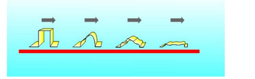

*As a pulse travels down a wire it slowly degenerates until it is lost in the electrical noise*

When there is only one device driving the bus the situation is particularly simple. The driving device only has to select which other device on the bus is being addressed and which way the data will flow. This is a simple bi-directional bus and again there are bus buffers, tri-state buffers, that can be set into one of three states – driving, listening or inactive.

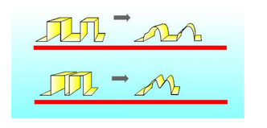

f two pulses are too close together then after travelling a short way you can’t tell that they are two pulses

## The big bus

There are many things that are important about a bus but the one that most users would list high is the capacity of the bus. Any given data connection has a limit in terms of the amount of data it can transfer in a given time. Typical units of bus capacity are Kbytes/s and Mbytes/s but you will also find, confusingly, Kbits/s and Mbits/s. The problem is when you see Kb/s does it mean thousands of bytes or bits per second? In general a lower case “b” means bits and an upper case “B” means bytes but you should always check if it isn’t obvious from the context.

What matters in determining the data capacity of a bus is how many wires it has – its width – and how long it takes to transmit a single bit of data down one of the wires. As already discussed, this is limited by the physical design of the bus – there is a highest frequency pulse that will make it from one end of the bus to the other. In addition to this physical limitation there is also the problem of co-ordinating the data transfer. Generally there are additional lines in the bus that control the flow of data. There is often a read/write line that indicates the direction of data flow, a data valid signal and sometimes a data accepted signal.

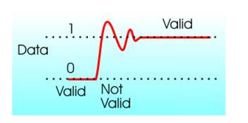

The signal on a bus cannot change instantaneously; it needs time to settle

The usual sequence of events is that the device driving the bus puts data onto it by driving the bus lines high or low. It then waits for a fixed time for the bus to become stable and sets a “data valid” line high. At this point any device that is reading data from the bus can assume that it is ok to start reading it. As soon as the device is finished it sets a data accepted line which lets the driving device know that it can move on to the next data item.

Notice that this description is very general and not of any particular bus. In practice they all do things slightly differently from one another in an effort to improve efficiency of data transfer or to provide additional sophistication. For example, if more than one device can drive the bus – become a “bus master” in the jargon – then you need extra signals to negotiate and determine who is the bus master at any moment.

As soon as you start adding the needs of the real world a bus can begin to seem very complex but if you concentrate on what each part is doing in turn it never turns out to be that difficult.

For example, the processor bus connects the memory to the processor but the control lines which select which memory location will be used are usually separated out in to a bus of their own – the address bus. In general the need to select which devices are active on the bus is the one that succeeds in complicating things the most.

## Synchronous and asynchronous

Whenever you build some piece of computer hardware you always have the choice of using either a synchronous or asynchronous bus. In the case of a synchronous bus there is a clock signal which sets the speed that everything happens at. Each clock pulse sets the timing for the entire data exchange on a bus and any device that connects to the bus has to be capable of working at this speed.

An asynchronous bus uses signals generated by the devices connected to it to regulate the flow of data. In this case the bus may have a maximum speed but if a slow device needs more time to transfer data it can have it. In practice things are never this clear cut and engineers find ways of slowing down synchronous buses. For example, the CPU to memory bus uses “wait” cycles, in effect bus clock pulses when nothing happens, to allow slow memory chips to work with a faster processor.

## Serial

One final piece of jargon that you will encounter is the term “serial” bus. A serial bus just has one wire to transfer data and perhaps one or two additional wires to control the transfer. It is obvious that to send say a byte of data it is going to have to be broken down and sent bit-by-bit and then reassembled. However even if a bus has more than one wire, i.e. if it is a parallel bus, it is usually necessary to send data as multiple transfers.

The distinction between a serial bus and a parallel bus is a fairly artificial one in this sense but there is a very different philosophy implied by the word “serial”. Until recently the best-known example of a serial bus was the RS232 socket on the back of most PCs. It didn’t really qualify as a bus because in general it could only connect two devices but today there are real serial buses that have mostly replaced it - USB and to a lesser extent FireWire or IEEE –1394. Because of their simplicity and because they don't have the drawback of signals leaking between multiple data lines a serial bus can achieve data transfer speed that exceed most parallel buses.

## Networks and buses

There is a connection between networks and buses that is worth knowing about. When a bus can have multiple bus masters then the big problem is working out which one is the master at any given moment. The simplest solutions e.g. first come first served, do not work very well because of the problem of bus hogging. For example, if a graphics processor decided that it should download 100Mbytes of data and grabbed the memory bus then the user might just notice the rest of the machine come to a halt.

One simple solution is to reduce the maximum amount of data that can be transferred in a single bus acquisition. This works but notice that in general the efficiency of a shared bus goes up with the size of the data block.

Even so breaking data transfer up into packets is one of the main ways of sharing a bus between bus masters. Now you might begin to see the connection between a bus and a network. What else is a network than a bus with multiple bus masters? A network can be regarded as a serial bus with a sophisticated bus mastering scheme.

What is important about this observation, apart from it being a new way of looking at things, is that as computers develop they are starting to make use of high speed bus architectures that look more like networks than traditional simple buses.

When the processor wants to send some data to the memory it just sends a packet off, complete with a suitable address. The memory or any other device connected to the bus can pick up data that is addressed to it or send data to another device in the same way. The PCI bus and its sucessor the serial PCI Express bus has some of these characteristics in that any device can pass data to any other device but neither work fast enough to be the main bus connecting the processor to memory. Some experimental high-speed computers have been built using networking techniques to connect all of the machine’s components together. This is the way that PCs will be built in the future and then you will not only have a network outside of the box but inside as well.

# About the I/O buses

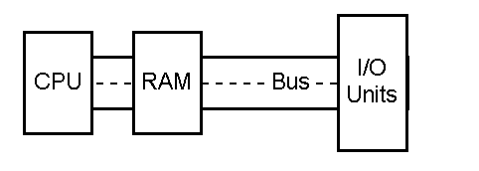

|  |  |
| --- | --- |
| Introduction to the I/O buses | [[top]](http://www.karbosguide.com/hardware/module2c1.htm#top) |

|  |  |
| --- | --- |
| We have seen before, that the PC's buses are the fundamental data "highways" on the system board. The "first" bus is the *system bus*, which connects the CPU with RAM. In older designs it was a local bus. In newer designs this bus is called the front side bus (FSB).  The typical local bus has a speed and width depending on the type CPU installed on the motherboard. Typically, the system bus will be 64 bits wide and run at 66, 100 or 133 MHz. These high speeds create electrical noises and other problems. Therefore, the speed must be reduced for data reaching the expansion cards and other more peripheral components. |  |

Very few expansion cards can operate at more than 40 MHz. Then the electronics shut down. The chips can just not react faster. Therefore, the PC has additional buses.

### Originally only one bus

However, the first PCs had only one bus, which was common for the CPU, RAM and I/O components:

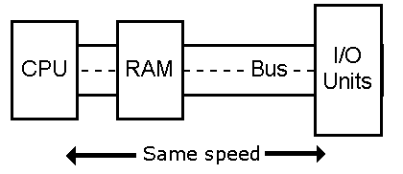

The older first and second generation CPUs ran at relatively low clock frequencies, and all system components could keep up with those speeds.

### RAM on adapters

Among other things, that allowed additional RAM to be installed in expansion slots in the PC, by installing an adapter in a vacant expansion slot. An adapter, where RAM was mounted:

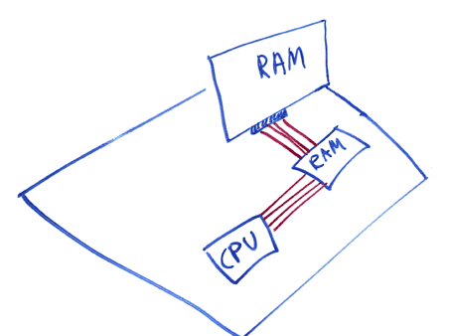

This setup would be unthinkable today. However it is truely a local bus. All units are united on one bus using the same clock.

First in 1987, Compaq figured out how to separate system bus from I/O bus, so they could run at different speeds. This multi-bus architecture has been industry standard ever since. Modern PCs also have more than one I/O bus.

|  |  |
| --- | --- |
| What does an I/O bus do? | [**[top]**](http://www.karbosguide.com/hardware/module2c1.htm#top) |

I/O buses connect the CPU to all other components, except RAM. Data are moved on the buses from one component to another, and data from other components to the CPU and RAM. The I/O buses differ from the system bus in speed. Their speed will always be lower than the system bus speed. Over the years, different I/O buses have been developed. On modern PCs, you will usually find four buses:

• The ISA bus, which is an old low speed bus, soon to be excluded from the PC design.

• The PCI bus, which is a new high speed bus.

• The USB bus (*Universal Serial Bus)*, which is a new low speed bus.

• The AGP bus which solely is used for the graphics card.

As mentioned earlier, I/O buses are really extensions to the system bus. On the motherboard, the system bus ends in a controller chip, which forms a bridge to the I/O buses.

All in all, the buses have had a very central placement in the PC's data exchange. Actually, all components except the CPU communicate with each other and with RAM via the different I/O buses. Here you see a demonstration of this logic:

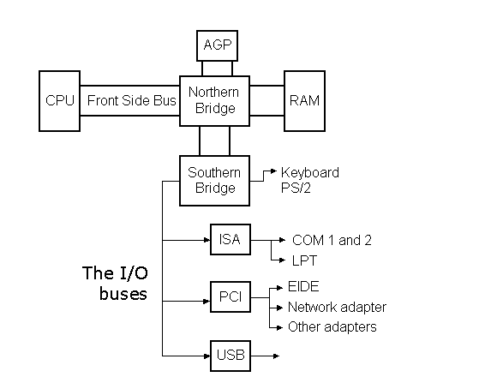

|  |  |
| --- | --- |
| • The physical aspects of the I/O buses | [**[top]**](http://www.karbosguide.com/hardware/module2c1.htm#top) |

Physically, the I/O bus consists of tracks on the printed circuit board. These tracks are used as:

• Data tracks, which each can move one bit at a time

• Address tracks, which identify where data should be sent to

• Other tracks for clock ticks, voltage, verification signals, etc.

When data are sent on the bus, they must be supplied with a *receiver*. Therefore, each device on the bus has an address. Similarly, the RAM is divided in sections, each having its address. Prior to sending data, a number is sent on the address track, to identify where the data should be sent to.

### The bus width

The number of data tracks determine the data transfer capacity. The ISA bus is slow, partly because it only has 16 data tracks. The modern PCs send 32 bits per clock tick. On the ISA bus, 32 bits must be divided in two packages of 16 bits. This delays the data transfer. Another I/O bus concept is *wait states.*

### Wait states

Wait states are small pauses. If an ISA adapter cannot keep up with the incoming data flow, its controller sends wait states to the CPU. Those are signals to the CPU to "hold on for a sec." A wait state is a wasted clock tick. The CPU skips a clock tick, when not occupied. Thus the old and slow ISA adapter can significantly reduce the operating speed of a modern computer.

Another aspect is the [IRQ](http://www.karbosguide.com/hardware/module5a3.htm#IRQ) signals, which the components use to attract attention from the CPU. That and the concepts *DMA* and *bus mastering,* are described in module 5, which deals with adapters.

|  |  |
| --- | --- |
| Technical and historical background for the I/O buses | [**[top]**](http://www.karbosguide.com/hardware/module2c1.htm#top) |

In modern PCs you only find the PCI and ISA buses (besides USB, which we do not know much about yet). But, over the years, there have been other buses. Here is a diagram of the various I/O buses. Then comes a more detailed description of each of the buses:

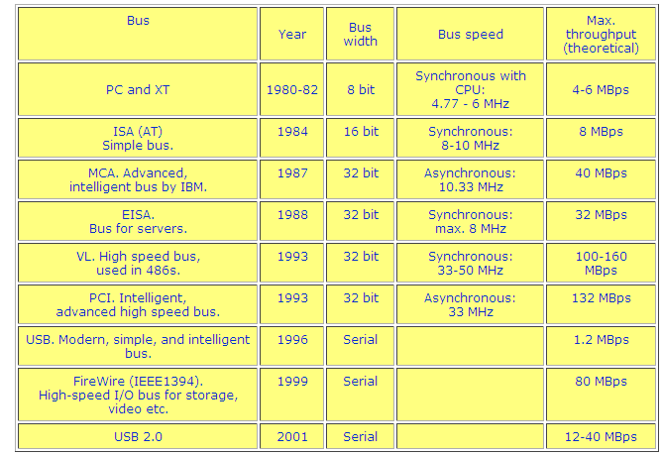

If you've ever taken the case off of a computer, you've seen the one piece of equipment that ties everything together -- the **motherboard**. A motherboard allows all the parts of your computer to receive power and communicate with one another.  
  
In market it looks something like this...

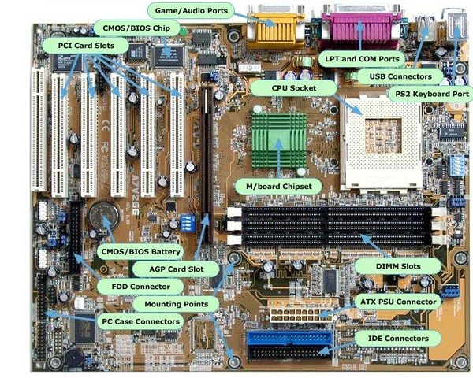

Motherboards have come a long way in the­ last twenty years. The first motherboards held very few actual components. The first IBM [PC](http://computer.howstuffworks.com/pc.htm) motherboard had only a processor and card slots. Users plugged components like floppy drive controllers and memory into the slots.  
Today, motherboards typically boast a wide variety of built-in features, and they directly affect a computer's capabilities and potential for upgrades.  
  
Let's look at the general components of a motherboard. Then, we'll closely examine five points that dramatically affect what a computer can do.

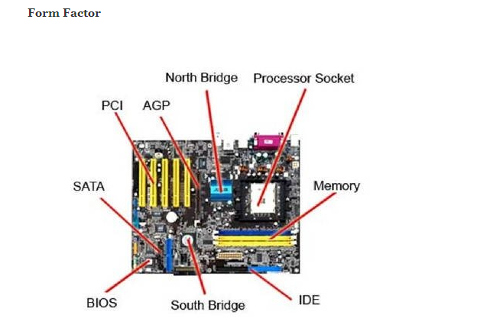

A motherboard by itself is useless, but a computer has to have one to operate. The motherboard's main job is to hold the computer's microprocessor chip and let everything else connect to it. Everything that runs the computer or enhances its performance is either part of the motherboard or plugs into it via a slot or port.  
  
The shape and layout of a motherboard is called the **form factor**. The form factor affects where individual components go and the shape of the computer's case. There are several specific form factors that most PC motherboards use so that they can all fit in standard cases. For a comparison of form factors, past and present, check out [Motherboards.org](http://www.motherboards.org/articles/tech-planations/4_1.html).  
The form factor is just one of the many standards that apply to motherboards. Some of the other standards include:

* The **socket for the microprocessor** determines what kind of Central Processing Unit (CPU) the motherboard uses.
* The **chipset** is part of the motherboard's logic system and is usually made of two parts -- the northbridge and the southbridge. These two "bridges" connect the CPU to other parts of the computer.
* The **Basic Input/Output System (BIOS)** chip controls the most basic functions of the computer and performs a self-test every time you turn it on. Some systems feature dual BIOS, which provides a backup in case one fails or in case of error during updating.
* The **real time clock chip** is a battery-operated chip that maintains basic settings and the system time.

The slots and ports found on a motherboard include:

* [Peripheral Component Interconnect](http://computer.howstuffworks.com/pci.htm) (PCI)- connections for video, sound and video capture cards, as well as network cards
* [Accelerated Graphics Port](http://computer.howstuffworks.com/agp.htm) (AGP) - dedicated port for video cards.
* [Integrated Drive Electronics](http://computer.howstuffworks.com/ide.htm) (IDE) - interfaces for the hard drives
* [Universal Serial Bus](http://computer.howstuffworks.com/usb.htm) or [FireWire](http://computer.howstuffworks.com/firewire.htm) - external peripherals
* [Memory](http://computer.howstuffworks.com/computer-memory.htm) slots

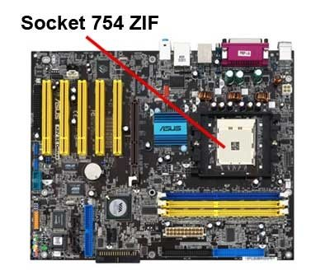A Socket 754 motherboard  
Photo courtesy: [Consumer Guide Products](http://electronics.howstuffworks.com/tech)  
  
Some motherboards also incorporate newer technological advances:

* [Redundant Array of Independent Discs](http://computer.howstuffworks.com/scsi.htm) (RAID) controllers allow the computer to recognize multiple drives as one drive.
* [**PCI Express**](http://computer.howstuffworks.com/pci-express.htm) is a newer protocol that acts more like a network than a bus. It can eliminate the need for other ports, including the AGP port.
* Rather than relying on plug-in cards, some motherboards have**on-board** sound, networking,video or other peripheral support.

Many people think of the CPU as one of the most important parts of a computer. We'll look at how it affects the rest of the computer in the next section.  
  
**Sockets and CPUs**  
  
The CPU is the first thing that comes to mind when many people think about a computer's speed and performance. The faster the processor, the faster the computer can think. In the early days of PC computers, all processors had the same set of pins that would connect the CPU to the motherboard, called the **Pin Grid Array** (PGA). These pins fit into a socket layout called **Socket 7**. This meant that any processor would fit into any motherboard.  
  
Today, however, CPU manufacturers Intel and AMD use a variety of PGAs, none of which fit into Socket 7. As microprocessors advance, they need more and more pins, both to handle new features and to provide more and more power to the chip.  
Current socket arrangements are often named for the number of pins in the PGA. Commonly used sockets are:

* **Socket 478** - for older Pentium and Celeron processors
* **Socket 754** - for AMD Sempron and some AMD Athlon processors
* **Socket 939** - for newer and faster AMD Athlon processors
* **Socket AM2** - for the newest AMD Athlon processors
* **Socket A** - for older AMD Athlon processors

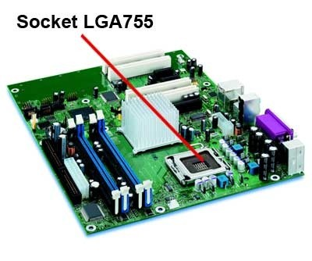

**A Socket LGA755 motherboard**  
Photo courtesy: [Shopper](http://shopper.howstuffworks.com/)  
  
The newest Intel CPU does not have a PGA. It has an LGA, also known as Socket T. LGA stands for Land Grid Array. An LGA is different from a PGA in that the pins are actually part of the socket, not the CPU. Anyone who already has a specific CPU in mind should select a motherboard based on that CPU. For example, if you want to use one of the new multi-core chips made by Intel or AMD, you will need to select a motherboard with the correct socket for those chips. CPUs simply will not fit into sockets that don't match their PGA.  
The CPU communicates with other elements of the motherboard through a chipset.   
  
**Chipsets**  
The chipset is the "glue" that connects the microprocessor to the rest of the motherboard and therefore to the rest of the computer. On a PC, it consists of two basic parts -- the **northbridge** and the **southbridge**. All of the various components of the computer communicate with the CPU through the chipset. The northbridge connects directly to the processor via the front side bus (FSB). A memory controller is located on the northbridge, which gives the CPU fast access to the memory.   
  
**Bus Speed**

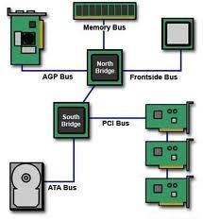

A bus is simply a circuit that connects one part of the motherboard to another. The more data a bus can handle at one time, the faster it allows information to travel. The **speed** of the bus, measured in megahertz (MHz), refers to how much data can move across the bus simultaneously.  
Bus speed usually refers to the speed of the **front side bus** (FSB), which connects the CPU to the northbridge. FSB speeds can range from 66 MHz to over 800 MHz. Since the CPU reaches the memory controller though the northbridge, FSB speed can dramatically affect a computer's performance.  
Here are some of the other busses found on a motherboard:

* The **back side bus** connects the CPU with the level 2 (L2) cache, also known as secondary or external cache. The processor determines the speed of the back side bus.
* The **memory bus** connects the northbridge to the memory.
* The **IDE** or **ATA** bus connects the southbridge to the disk drives.
* The **AGP** bus connects the video card to the memory and the CPU. The speed of the AGP bus is usually 66 MHz.
* The **PCI** bus connects PCI slots to the southbridge. On most systems, the speed of the PCI bus is 33 MHz.

The faster a computer's bus speed, the faster it will operate -- to a point. A fast bus speed cannot make up for a slow processor or chipset.  
Now let's look at memory and how it affects the motherboard's speed.  
  
**Memory and Other Features**  
  
We've established that the speed of the processor itself controls how quickly a computer thinks. The speed of the chipset and busses controls how quickly it can communicate with other parts of the computer. The speed of the RAM connection directly controls how fast the computer can access instructions and data, and therefore has a big effect on system performance. A fast processor with slow RAM is going nowhere.  
  
The amount of memory available also controls how much data the computer can have readily available. RAM makes up the bulk of a computer's memory. The general rule of thumb is the more RAM the computer has, the better.  
Much of the memory available today is **dual data rate** (DDR) memory. This means that the memory can transmit data twice per cycle instead of once, which makes the memory faster. Also, most motherboards have space for multiple memory chips, and on newer motherboards, they often connect to the northbridge via a dual bus instead of a single bus. This further reduces the amount of time it takes for the processor to get information from the memory.

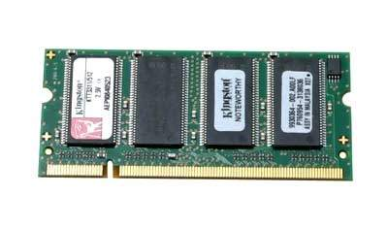

**200-pin DDR SODIMM RAM**  
Photo courtesy: [Shopper](http://shopper.howstuffworks.com/)  
A motherboard's memory slots directly affect what kind and how much memory is supported. Just like other components, the memory plugs into the slot via a series of pins. The memory module must have the right number of pins to fit into the slot on the motherboard.

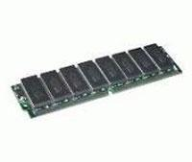

64MB SDRAM SIMM  
Photo courtesy: [Shopper](http://shopper.howstuffworks.com/)  
In the earliest days of motherboards, virtually everything other than the processor came on a card that plugged into the board. Now, motherboards feature a variety of onboard accessories such as LAN support, video, sound support and RAID controllers.

[**History Of The Computer Motherboard – Infographic!**](http://bloggedd.com/history-of-the-computer-motherboard-infographic/)

Posted by [admin](http://bloggedd.com/author/admin/)

[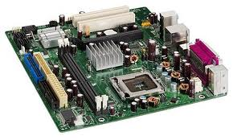](http://bloggedd.com/wordpress/wp-content/uploads/2012/09/images4.jpg)

A **motherboard** (sometimes alternatively known as the **mainboard**, **system board**, **planar board** or **logic board**) is a printed circuit board (PCB) found in all modern computers, which holds many of the crucial components of the system, such as the central processing unit (CPU) and memory, and provides connectors for other peripherals.

Motherboard specifically refers to a PCB with expansion capability. The term mainboard is applied to devices with a single board and no additional expansions or capability. In modern terms this would include controlling boards in televisions, washing machines and other embedded system.

**A motherboard contains history. Here is the detail of history:**

* In 1981 IBM “planar” Breadboard was the first motherboard used in a PC, chips were wired together and in housed RAM and CPU with supplier parts and keyword/cassette tapes.
* In 1984 IBM came up with the AT{ Advanced Technology } design that the component based PC which we know today was born. The AT form factor proved very popular and became a standardised motherboard to fit all desktops and tower cases.
* In 1986 Birth of Gigabyte formed by Yeh pei-cheng in Taiwan.
* In 1987 Elitegroup former world’s largest motherboard manufacturer creator of ECS boards.
* In 1989 a small Taiwanese company formed by former ACER employees took their name from Pegasus, they would later become the world’s biggest motherboard manufacturer.
* In 1993 – Intel Develops PAGA for settings – Plastic pin grid array was developed by Intel in 1993. It assisted in integrated circuit packaging.
* In 1995 – Intel Releases new Motherboard ATX form factor – The ATX was first major motherboard development since the AT in 1984. Featuring many improvements including new dimensions and layout improving space and interchange ability of parts, it solved many issues faced by system builders from the original AT.
* In 1997 – Intel begins manufacturer Motherboards – Intel starts its own motherboard division with a great reputation stability.
* In 1998 – Micro ATX boards produced – The first backward compatible board that although nearly half the size of a standard ATX board was fully compatible, usually they contain more integrated peripherals and are made for smaller case PCs, but less expansion stats.
* In 2001 – Mini ITX produced by VIA – The small ITX seized motherboard was launched in 2001 and was built for small cases. Yet still manages to pack out all the features of aregular ATX but again with less just the one and performance as an ATX and Micro ATX.
* In 2005 – Intel introduces balanced Technology Extended – Intel’s concept to redesign the ATX case was short lived. Mainly because compatible components where limited, as well as it not being able to accept energy efficient components.
* In 2007 – ASUS Tek Becomes World’s Largest maker of computer motherboards – Intel’s concept to redesign the ATX case was short lived. Mainly because compatible components where limited. As well as it not being able to accept energy efficient components.
* In 2009 – The Mobile ITX – As of 2012, VIAS Mobile – ITX is the world’s smallest complaint motherboard form factor. Just 60 MM by 60 MM.

This infographic published by [**palicomp**](http://www.palicomp.co.uk/)**. Take  a look:**

## SMT Solder Paste Screen Printer Machine for Solder Paste Screen Printing

Santosh Das July 31, 2015   [Electronics](http://www.electronicsandyou.com/blog/category/electronics), [SMT](http://www.electronicsandyou.com/blog/category/smt), [Soldering](http://www.electronicsandyou.com/blog/category/soldering)   [2 Comments](http://www.electronicsandyou.com/blog/smt-solder-paste-screen-printer-machine-for-solder-paste-screen-printing.html#comments)

A Solder Paste Screen Printer for SMT is needed to screen solder paste onto the printed circuit board (PCB) before placement of surface mount components.

Solder Paste Screen Printer for SMT have been widely used in electronics by the PCB industry for screen solder mask. This equipment / machine has also been extensively used in the hybrid industry for screening solder paste. However, different equipment is used for the screening of solder mask and solder paste. The cost of screen printers can vary widely, depending on their degree of automation and the size of boards they can handle.

[Solder Paste](http://www.electronicsandyou.com/blog/solder-paste-and-its-application-in-smt.html) Printing Systems are available in three configurations: manual, semi-automatic and fully automatic. The machine can be table mounted, stand-alone, or in-line. Many semi-automatic printers offer manual vision alignment capability, while fully automatic printers offer automatic vision alignment.

**Stencil Vs Screen Printing**

Stencils are preferred over screens because of better image accuracy, volume

[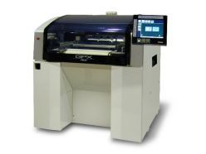](http://www.electronicsandyou.com/blog/wp-content/uploads/2013/11/Solder-Paste-Screen-Printer-Machine.jpg)

Solder Paste Screen Printer Machine

control, and longer service life. Screens are not in common use today. Stainless steel is the most common stencil material. Other choices include brass 42 and molybdenum. Chemical etching is commonly used to fabricate stencils.

Several other methods have been developed to aid fine pitch applications including plating (electroless nickel), electrodeposition, laser cutting, and electropolishing. Stepped thickness stencils have been developed to apply various thickness of solder paste to different component types on a substrate. Fine pitch printing require very accurate alignment of the stencil apertures to the land patterns

**SMT Dictionary – Surface Mount Technology Acronym and Abbreviation**

Santosh Das July 31, 2015   [Electronics](http://www.electronicsandyou.com/blog/category/electronics), [SMT](http://www.electronicsandyou.com/blog/category/smt)   [1 Comment](http://www.electronicsandyou.com/blog/smt-dictionary-surface-mount-technology-acronym-and-abbreviation.html#comments)

SMT (Surface Mount Technology) is a packaging technology in electronics that mounts electronic components on the surface of a Printed Circuit Board / Printed Wiring Board (PCB / PWB) instead of inserting them through holes of the board. SMT or Surface Mount Technology is relatively new technology in [electronics](http://www.electronicsandyou.com/blog/top-electronic-companies-in-the-world.html) and provides state-of-art, miniature electronics products at reduced weight, volume and cost.

History of SMT is rooted in the technology of Flat Packs (FP) and hybrids of 1950s and 1960s. But for all practical purposes, today’s SMT can be considered

[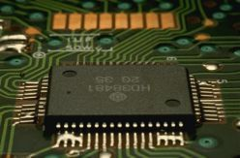](http://www.electronicsandyou.com/blog/wp-content/uploads/2013/11/SMT-Surface-Mount-Technology.jpg)

SMT (Surface Mount Technology)

to be a continually evolving technology. Currently the use of Fine Pitch, Ultra Fine Pitch (UFP) and Ball Grid Arrays (BGAs) are becoming even more common.

Even the next level of packaging technologies such as Chip-on-Board (COB), Tape-Automated Bonding (TAB), and Flip Chip Technologies are gaining widespread acceptance. Multichip Modules (MCMs) using wire bond, TAB, or Flip Chip are used to achieve the highest performance possible but with a cost premium.

*Here I explain SMT acronyms and abbreviations.*

**SMT Dictionary**

1. **A-Stage**: The condition of low molecular weight of a resin polymer during which the resin is readily soluble and fusible.
2. **Anisotropic**: A material fillet with a low concentration of large conductive particles designed to conduct electricity in the Z axis but not the X or Y axis. Also called Z axis adhesive.
3. **Annular Ring**: The conductive material around a drilled hole.
4. **Aqueous Cleaning**: A water-based cleaning methodology which may include the addition of the following chemicals: neutralizers, saponifiers, and surfactants. May also use DI (Deionized) water only.
5. **Aspect Ratio**: A ratio of the thickness of the board to its preplated diameter. A via hole with aspect ratio greater than 3 may be susceptible to cracking.
6. **Azeotrope**: A blend of two or more polar and non polar solvents that behaves as a single solvent or remove polar and nonpolar contaminants. It has one boiling point like any other single component solvent, but it boils at a lower temperature than either of its constituents. The constituents of the azeotrope cannot be separated.
7. **B. Stage**: Sheet material (e.g., glass fabric) impregnated with a resin cured to an intermediate stage.
8. [**Ball Grid Array (BGA)**](http://www.electronicsandyou.com/blog/bga-ball-grid-array-repairing-and-soldering-bga.html): Integrated circuit package in which the input and output points are solder balls arranged in a grid pattern.
9. **Blind Via**: A via extended from an inner layer to the surface.
10. **Blowhole**: A large void in a solder connection created by rapid outgassing during the soldering process.
11. **Bridge**: Solder that bridges across two conductors that should not be electrically connected, thus causing an electrical short.
12. **Buried Via**: A via hole connecting internal layers that does not extend to the board surface.
13. **Butt Joint**: A surface mount device lead that is sheared, so that the end of the leads contacts the board and land pattern.
14. **C-Stage Resin**: A resin in a final stage of cure.
15. **Capillary Action**: The combination of force, adhesion, and cohesion which causes liquids such as molten metal to flow between closely spaced solid surfaces against the force of gravity.
16. **Castellation**: Metallized semicircular radial features on the edges of LCCC’s that interconnect conducting surfaces. Castellations are typically found on four edges of a leadless chip carrier. Each lies within the termination area for direct attachment to the land patterns.
17. **CFC**: Chlorinated fluorocarbon, cause depletion of ozone layer and scheduled for restricted use by the environmental protection agency. CFC’s are used in air conditioning, foam insulation and solvents, etc.
18. **Characteristic Impedance**: The voltage-to-current ratio in a propagation wave, i.e., the impedance which is offered to the wave at any point of the line. In printed wiring its value depends on the width of the conductor to ground plane(s) and the dielectric constant to the media between them.
19. **Chip Component**: Generic term for any two-terminal leadless surface mount passive devices, such as resistors and capacitors.
20. **Chip-on-Board Technology**: Generic term for any component assembly technology in which an unpackaged silicon die is mounted directly on the printed wiring board. Connections to the board can be made by wire bonding, tape automated bonding (TAB), or flip-chip bonding.
21. **CLCC**: Ceramic leaded chip carrier.
22. **Cold Solder Joint**: A solder connection exhibiting poor wetting and a grayish, porous appearance due to insufficient heat or excessive impurities in the solder.
23. **Column Grid Array (CGA)**: Integrated Circuit (IC) package in which the input and output points are high temperature solder cylinders or columns arranged in a grid pattern.
24. **Component Side**: A term used in through-hole technology to indicate the component side of the PWB.
25. **Condensation Inert Heating**: A general term referring to condensation heating where the part to be heated is submerged into a hot, relatively oxygen-free vapor. The part, being cooler than the vapor, causes the vapor to condense on the part transferring its latent heat of vaporization to the part. Also known as vapor phase soldering.
26. **Constraining Core Substrate**: A composite printed wiring board consisting of epoxy-glass layers bound to a low thermal-expansion core material, such as copper-incar-copper, graphite-epoxy, and aramid fiber-epoxy. The core constrains the expansion of the outer layers to match the expansion coefficient of ceramic chip carriers.
27. **Contact Angle**: The angle of wetting between the solder fillet and the termination or land pattern. A contact angle is measured by constructing a line tangent to the solder fillet that passes through a point of origin located at the place of intersection between the solder fillet and termination or land pattern. Contact angles of less than 90 Degrees Celsius (Positive wetting angles) are acceptable. Contact angles less than 90 Degree Celsius (Negative wetting angles) are unacceptable.
28. **Control Chart**: A chart that tracts process performance over time. Trends in chart are used to identify process problems that may require corrective action to bring the process under control.
29. **Coplanarity**: The maximum distance between the lowest and the highest pin when the package rests on a perfectly flat surface. 0.004 inch maximum Coplanarity is acceptable for peripheral packages and 0.008 inch maximum for BGA.
30. **Crazing**: An internal condition that occurs in the laminated base material in which the glass fibers are separated from the resin at the weave intersections. This condition manifests itself in the form of connected white spots, of “cross,” below the surface of the base material, and is usually related to mechanically induced stress.
31. [**CTE (Coefficient of Thermal Expansion)**](http://www.electronicsandyou.com/blog/surface-mount-design-considerations-in-smt-cte-mismatching.html): The ratio of the change in dimensions to a unit change in temperature. CTE is commonly expressed in ppm/ degree Celsius.
32. **Delamination**: A separation between plies within the base material, or between the base material and the conductive foil, or both.
33. **Dentritic Growth**: Metallic filament growth between conductors in the presence of condensed moisture and electrical bias. (Also known as “whiskers.”)
34. **Design for Manufacturability**: Designing a product to be produced in the most efficient manner possible in terms of time, money, and resources taking into consideration how the product will be produced, utilizing the existing skill base (and avoiding the learning curve) to achieve the highest yields possible.
35. **Dewetting**: A condition that occurs when molten solder has coated a surface and then receded, leaving irregularly shaped mounds of solder separated by areas covered with a thin solder film. Voids may also be seen in the dewetted areas. Dewetting is difficult to identify since solder can be wetted at some locations and base metal may be exposed at other locations.
36. **Dielectric Constant**: A property that is a measure of a material’s ability to store electrical energy.
37. **DIP (Dual In-Line Package)**: A package intended for through-hole mounting that has two rows of leads extending at right angles from the base with standard spacing between leads and row.
38. **Disturbed Solder Joint**: A condition that results from motion between the joined members during solder appearance, although they may also appear lustrous.
39. **Drawbridging**: A solder open condition during reflow in which chip resistors and capacitor resemble a draw bridge.
40. **Dual-Wave Soldering**: A [wave soldering](http://www.electronicsandyou.com/blog/wave-soldering-equipment-process.html) process that uses a turbulent wave with a subsequent laminar wave. The turbulent wave ensures complete solder coverage in tight areas and the laminar wave removes bridges and icicles. Designed for soldering surface mount devices glued to the button of the board.
41. **Electroless Copper**: Copper plating deposited from a plating solution as a result of a chemical reaction and without the application of an electrical current.
42. **Electrolytic Copper**: Copper plating deposited from a plating solution by the application of an electrical current.
43. **Etchback**: The controlled removal of all components of base material by a chemical process on the side walls of holes in order to expose additional internal conductor areas.
44. **Eutectic**: The alloy of two or more metals that has a lower melting point than either of its constituents. Eutectic alloys, when heated, transform directly from a solid to a liquid and do not show pasty regions.
45. **Fiducial**: A geometric shape incorporated in the artwork of a printed wiring board, and used by a vision system to identify the exact artwork location and orientation. Generally three fiducial marks are used per board. Fiducial marks are necessary for the accurate placement of fine pitch packages. Both global and local fiducials can be used. Global fiducials (generally three) locate the overall circuitry pattern to the PCB, whereas local fiducials (one or two) are used at component locations, typically fine pitch patterns, to increase the placement accuracy. Also known as alignment target.
46. **Fillet**: (1) A radius or curvature imparted to inside meeting surfaces. (2) The concave junction formed by the solder between the footprint pad and the SMC lead or pad.
47. **Fine Pitch**: A center to center lead distance of surface mount packages of 0.025 inch or less.
48. **Flatpack**: An integrated circuit package with gull wing or flat leads on two or four sides, with standard spacing between leads. Commonly the leads pitches are at 50 mil centers, but lower pitches may also be used. The packages with lower pitches are generally referred to as fine pitch packages.
49. **Flip-Chip Technology**: A chip-on-board technology is which the silicon die is inverted and mounted directly to the printed wiring board. Solder is deposited on the bonding pads in vacuum. When inverted, they make contact with the corresponding board lands and the die rests directly above the board surface. It provides the ultimate is densification also known as C4 (controlled collapse chip connection).
50. **Footprint**: A nonpreferred term for Land Pattern.
51. **Functional Test**: A electrical test of an entire assembly that stimulates the intended function of the product.
52. **Glass Transition Temperature**: The temperature at which a polymer changes from a hard and relatively brittle condition to a viscous or rubbery condition. This transition generally occurs over a relatively narrow temperature range. It is not a phase transition. In this temperature region, many physical properties undergo significant and rapid changes. Some of those properties are hardness, brittleness, thermal expansion, and specific heat.
53. **Gull Wing Lead**: A lead configuration typically used on small outline packages where leads bend and out. An end view of the package resembles a gull in flight.
54. **Icicles (Solder)**: A sharp point of solder that protrudes out of a solder joint, but does not make contact with another conductor. Icicles are not acceptable.
55. **In-Circuit Test**: A electrical test of an assembly in which each component is tested individually, even though many electronic components are soldered to the board.
56. **Ionograph**: An instrument designed to measure board cleanliness (the amount of ions present on a surface). It extracts ionizable materials from the surface of the part to be measured and records the rate of extraction and the quantity.
57. **JEDEC**: Joint Electronic Devices Engineering Council.
58. **J-Lead**: A lead configuration typically used on plastic chip carrier packages which have leads that are bent underneath the package body. A side view of the formed lead resembles the shape of the letter “J”.
59. **Known Good Die**: Semiconductor die that has been tested and is known to function to specification.
60. **Laminar Wave**: A smoothly flowing solder wave with no turbulence.
61. **Land**: A portion of a conductive pattern usually, but not exclusively, used for the connection, or attachment, or both of components. (Also called a “pad”).
62. **Land Pattern**: Component mounting sites located on the substrate that is intended for the interconnection of a compatible Surface Mount Component. Land patterns are also referred to as “lands” or “pads”.
63. **LCC**: A nonpreferred term for “leadless ceramic chip carrier”.
64. **LCCC (Leadless Ceramic Chip Carrier)**: A ceramic, hermetically-sealed, integrated circuit (IC) package commonly used for military applications. The package has Metallized castellations on four sides for interconnecting to the substrate. (Also known as LCC).
65. **Leaching**: The dissolution of a metal coating, such as silver and gold, into liquid solder. Nickel barrier interplating is used to prevent leaching. Also known as scavenging.
66. **Lead Configuration**: The solid formed conductors that extend from a component and serve as a, mechanical and electrical connection that is readily formed to a desired configuration. The gull wing and J-lead are the most common surface mount lead configurations. Less common are butt leads formed by cutting standard DIP package leads at the knee.
67. **Lead Pitch**: The distance between successive centers of the leads of a component package.
68. **Legend**: Letters, numbers, symbols, and/or patterns on the PCB that are used to identify component locations and orientation for aid in assembly and rework / repair operations.
69. **Manhattan Effect**: A solder open condition during reflow in which chip resistors and capacitor resemble a draw bridge.
70. **Mass Lamination**: The simultaneous lamination of a number of pre-etched, multiple image, C-stage panels or sheets, sandwiched between layers of prepeg (B-stage) and copper foil.
71. **Mealing**: A condition at the interface of the conformal coating and base material, in the form of discrete spots or patches, which reveals a separation of the conformal coating from the surface of the printed board (PCB), or from the surfaces of attached components, or from both.
72. **Measling**: An internal condition that occurs in laminated base material in which the glass fibers are separated from the resin at the weave intersection. This condition manifests itself in the form of discrete white spots or “crosses” below the surface of the base material, and is usually related to the thermally induced stress.
73. **MELF**: A metal electrode leadless face surface mount device that is round, cylindrical passive component with a metallic cap termination located at each end.
74. **Metallization**: A metallic deposited on substrates and component terminations by itself, or over a base metal, to enable electrical and mechanical interconnections.
75. **Multichip Module (MCM)**: A circuit comprised of two or more silicon devices bonded directly to a substrate by wire bond, TAB, or flip chip.
76. **Multilayer Board**: A Printed Wiring Board (PWB/PCB) that uses more than two layers for conductor routing. Internal layers are connected to the outer layers by way of plated via holes.
77. **Neutralizer**: An alkaline chemical added to water to improve its ability to dissolve organic acid flux residue.
78. **No-Clean Soldering**: A [soldering process](http://www.electronicsandyou.com/blog/surface-mount-soldering-guide-smd-soldering.html) that uses a specially formulated [solder paste](http://www.electronicsandyou.com/blog/solder-paste-and-its-application-in-smt.html) that does not require the residues to be cleaned after [solder](http://www.electronicsandyou.com/blog/cored-solder-wire-all-about-flux-cored-solder-wire.html) processing.
79. **Node**: An electrical junction connection two or more component terminations.
80. **Nonwetting**: A condition whereby a surface has contacted molten solder, but has had part or none of the solder adhere to it. Nonwetting is recognized by the fact that the bare base metal is visible. It is usually caused by the presence of contamination on the surface to be soldered.
81. **Omegameter**: An instrument used to measure board cleanliness (ionic residues on the surface of PCB assemblies). The measurement is taken by immersing the assembly into a predetermined volume of a water-alcohol mixture with a known high resistivity. The instrument records and measures the drop of resistivity caused by ionic residue over a specified period of time.
82. **Ounces of Copper**: This refers to the thickness of copper foil on the surface of the laminate: ½ ounce copper, 1 ounce copper, and 2 ounce copper are common thickness. One ounce copper foil contains 1 ounce of copper per square foot of foil. The foil on the surface of the laminate may be designated for the copper thickness on both sides by: 1/1 = 1 ounce, two sides; 2/2 = 2 ounces, two sides; and 2/1 = 21 ounce on one side and 1 ounce on the other side. ½ ounce = 0.72 mil = 0.00072 inch; 1 ounce = 1.44 mils = 0.00144 inch; 2 ounces = 2.88 mils = 0.00288 inch.
83. **Outgassing**: De-aeration or other gaseous emission from a PCB or solder joint.
84. **PAD**: A portion of a conductive pattern usually, but not exclusively, used for the connection, attachment, or both of components. Also called a “Land”
85. **Pin Grid Array (PGA)**: Integrated circuit package in which the input and output points are through-hole pins arranged in a grid pattern.
86. **P/I Structure**: Packaging and interconnecting structure
87. **PLCC (Plastic Leaded Chip Carrier)**: A components package that has J-leads on four sides with standard spacing between leads.
88. **Prepreg**: Sheet material (e.g., glass fabric) impregnated with a resin cured to an intermediate stage (B-stage resin).
89. [**Printed Circuit Board (PCB) / Printed Wiring Board (PWB)**](http://www.electronicsandyou.com/blog/printed-circuit-board-pcb-for-surface-mount-technology-smt.html): The general term for completely processed printed circuit configuration. It includes rigid or flexible, single, double, or multilayer boards. A substrate of epoxy glass, clad metal, or other material upon which a pattern of conductive traces is formed to interconnect electronic components. Printed Wiring Assembly (PWA): A printed wiring board on which separately manufactured components are parts have been added. The generic term for a printed wiring board after all electronic components have been completely attached / soldered. Also called “printed circuit assembly”.
90. **Profile**: A graph of time versus temperature.
91. **PTH (Plated Through Hole)**: A plated via used as an interconnection between top and bottom sides or inner layers of a PWB/PCB. Intended for mounting component leads into through-hole technology.
92. **Quadpack**: Generic term for SMT packages with leads on all four sides. Most commonly used to describe packages with gull wing leads. Also known as flat pack, but flat packs may have gull wing leads on either two or four sides.
93. **Reference Designator**: A combination of letter and numbers that identify the class of the component on an assembly drawing.
94. **Reflow Soldering**: A process of joining metallic surfaces (without the melting of base metals) through the mass heating of preplaced solder paste to solder fillets in the Metallized area.
95. **Resin Recession**: The presence of voids between the barrel of the plated through hole and the wall of the holes, seen in cross-sections of plated through holes in boards that have been exposed to high temperatures.
96. **Resin Smear**: A condition usually caused by drilling in which the resin is transferred from the base material to the wall of a drilled hole covering the exposed edge of the conductive pattern. Resist: Coating material used to mask or protect selected areas of a pattern from the action of an etchant, solder, or plating.
97. **Saponifier**: An alkaline chemical, when added to water, makes it soapy and improves its ability to dissolve rosin flux residue.
98. **Secondary Side**: the side of the assembly that is commonly referred to as the solder side in through hole technology. In SMT, the secondary side may be either reflow soldered (active components) or wave soldered (passive components).
99. **Self-Alignment**: Due to the surface tension of molten solder, the tendency of slightly misaligned components (during placement) to self align with respect to their land pattern during reflow soldering. Minor self-alignment is possible, but one should not count on it.
100. **Semi-Aqueous Cleaning**: This cleaning technique involves a solvent cleaning step, hot water rinses, and a drying cycle.
101. **Shadowing (Solder)**: A condition in which solder fails to wet the surface mount device leads during wave soldering process. Generally the trailing terminations of a component are affected, because the component body blocks the proper flow of solder. Requires proper component orientation during wave soldering to correct the problem.
102. **Shadowing (Infrared Reflow)**: A condition in which component bodies block radiated infrared energy from striking certain areas of the board directly. Shadowing areas receive less energy than their surroundings and may not reach a temperature sufficient to completely melt the solder paste.
103. **Single-Layer Board**: A PWB that contains Metallized conductors on only one side of the board. Through-holes are unplated.
104. **Single-Wave Soldering**: A wave soldering process that uses only a single, laminar wave to form the solder joints. Generally not used for wave soldering.
105. **SMC**: A surface mount component
106. [**SMD**](http://www.electronicsandyou.com/blog/smd-surface-mount-electronic-components-for-smt.html): A surface mount device. Registered service mark of North American Philips Corporation to denote resistor, capacitor, SOIC and SOT.
107. **SMOBC (Solder Mask Over Bare Copper)**: The technology of using solder mask to protect the external bare copper circuitry from oxidation, and for coating the exposed copper circuitry with tin-lead solder.
108. [**SMT (Surface MountTechnology)**](http://www.electronicsandyou.com/blog/category/smt): A method of assembling printed wiring boards or hybrid circuitry, where components are mounted onto the surface rather than inserted into through-holes.
109. **SOIC (Small Outline Integrated Circuit)**: An integrated surface mount package with two parallel rows of gull-wing leads, with standard spacing between leads and rows.
110. **SOJ (Small Outline J-Leaded)**: An integrated circuit surface mount package with two parallel rows of J-Leads, with standard spacing between leads and rows. Generally used for memory devices.
111. **Solder Balls**: Small spheres of solder adhered to laminate, mask, or conductors. Solder Balls are most often associated with the usage of solder paste containing oxides. Baking of paste may minimize formation of solder balls, but overbaking may cause excessive balling.
112. **Solder Bridging**: The undesirable formation of a conductive path by solder between conductors.
113. **Solder Fillet**: A general term used to describe the configuration of a solder joint that was formed with a component lead or termination and a PWB land pattern.
114. [**Solder Flux**](http://www.electronicsandyou.com/blog/solder-flux-basics.html): Solder flux or simply flux is a kind of chemical used by electronic companies in electronics industry to clean surfaces of PCB before soldering electronic components onto the board. The main function of using flux in any PCB assembly or rework is to clean and remove any oxide from the board.
115. **Solder Paste / Solder Cream**: A homogeneous combination of minute spherical solder particles, flux, solvent, and a gelling or suspension agent used in surface mount reflow soldering. Solder paste can be deposited on a substrate via solder dispensing and screen or stencil print.
116. **Solder Side**: A term used in through-hole technology to indicate the soldered side of PWB.
117. **Solder Wicking**: The capillary action of molten solder to a pad or component lead. In the case of leaded packages, excessive wicking can lead to an insufficient amount of solder at the lead/pad interface. It is caused by rapid heating during reflow or excessive lean Coplanarity, and is more common in the vapor phase than in IR soldering.
118. **Solvent**: Any solution capable of dissolving a solute. In the electronics industry, aqueous, semi-aqueous and non-ozone-depleting solvents are used.
119. **Solvent Cleaning**: The removal of organic and inorganic soils using a blend of polar and nonpolar organic solvents.
120. **SOT (Small Outline Transistor)**: A discrete semiconductor surface mount package that has two gull wing leads on one side of the package and one on the other side.
121. **Squeegee**: A rubber or metal blade used in screen and stencil printing to wipe across the screen/stencil to force the solder paste through the screen mesh or stencil apertures onto the land pattern of the PCB. Stencil: A thick sheet of Metallic Material with a circuit pattern cut into it.
122. **Surface Insulation Resistance (SIR)**: A measure in ohms of the insulating material’s electrical resistance between conductors.
123. **Surfactant**: Contracting of “Surface active agent.” A chemical added to water in order to lower surface tension and allow penetration of water under tighter spaces.
124. **TAB (Tape Automated Bonding)**: The process of mounting the integrated circuit die directly on the surface of the substrate, and interconnecting the two together using a fine lead frame.
125. **Tape Carrier Package (TCP)**: Same as TAB
126. **Tenting**: A printed board fabrication method of covering over plated via holes and the surrounding conductive pattern with a resist, usually dry film.
127. **Termination**: The metallization surfaces, or in some cases, metal end clips on the end of passive chip components.
128. **Thixotropic**: The characteristic of a liquid or gel that is viscous when static, yet fluid when physically “worked.”
129. **Tombstoning**: Same as Drawbridging.
130. **Type I SMT Assembly**: An exclusive SMT PCB assembly with components mounted on one or both sides of the substrate.
131. **Type II SMT Assembly**: A mixed technology PCB assembly with SMT components mounted on one or both sides of the substrate and through-hole components mounted to the primary or component side.
132. **Type III SMT Assembly**: A mixed technology PCB assembly with passive SMT components and occasionally SOICs (small outline integrated circuits) mounted on the secondary side of the substrate and through-hole components mounted to the primary or component side. Typically this type of assembly is wave soldered in a single pass.
133. **Ultra Fine Pitch**: A center lead distance of surface mount packages of 0.4mm or less.
134. **Vapor Phase Soldering**: Same as Condensation Inert Heating.
135. **Via Hole**: A plated through hole connecting two or more conductor layers of a multilayer PCB. There is no intention to insert a component lead inside a via hole.
136. **Void**: The absence of material in a localized area.
137. **Wave Soldering**: A process of joining metallic surfaces (without the melting of the base metals) through the introduction of molten solder to metallized areas. Surface mount devices are attached using adhesive and are mounted on the secondary side of the PWB.
138. **Weave Exposure**: A surface condition of base material in which the unbroken fibers of woven glass cloth are not completely covered by resin.
139. **Wetting**: A physical phenomenon of liquids, usually in contact with solids, wherein the surface tension of the liquid has been reduced so that the liquid flows and makes intimate contact in a very thin layer over the entire substrate surface. Regarding wetting of a metal surface by a solder flux reduces the surface tension of the metal surface and the solder, resulting in the droplets of solder collapsing into a very thin film, spreading, and making intimate contact over the entire surface.
140. **Wicking**: Absorption of liquids by capillary action along the fibers of the base metal.

[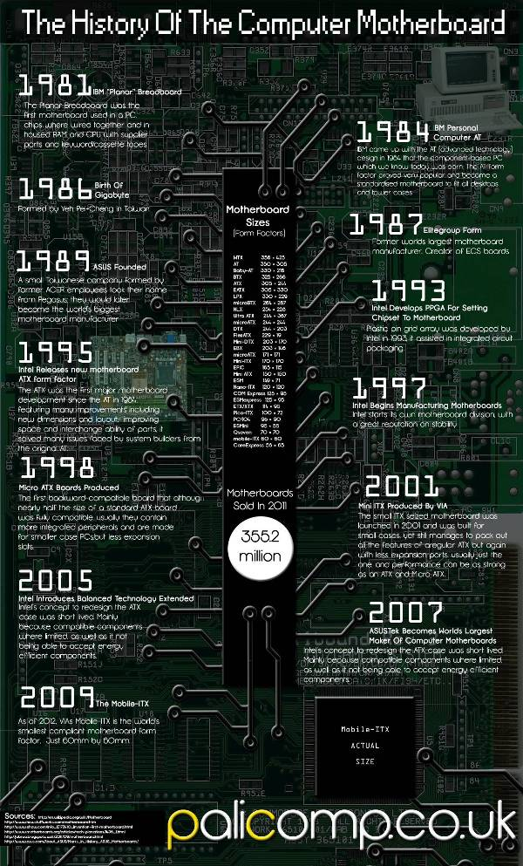](http://bloggedd.com/wordpress/wp-content/uploads/2012/09/infographic-history-of-the-computer-motherboard_506027137b099.jpg)

**Printed Circuit Board (PCB) for Surface Mount Technology (SMT)**

Santosh Das July 31, 2015   [Electronics](http://www.electronicsandyou.com/blog/category/electronics), [PCB](http://www.electronicsandyou.com/blog/category/pcb), [SMT](http://www.electronicsandyou.com/blog/category/smt)   [3 Comments](http://www.electronicsandyou.com/blog/printed-circuit-board-pcb-for-surface-mount-technology-smt.html#comments)

A printed circuit board, or PCB, is an integral part of electronics. A PCB is basically a substrate (normally made from glass epoxy) with conductive traces etched from copper sheets. These copper traces facilitate flow of electricity. Electronic components are soldered along this conductive pathway thus controlling the flow and quantity of electricity needed.

A Printed Circuit Board is also known as Printed Wiring Board (PWB). When all the [electronic components](http://www.electronicsandyou.com/blog/smd-surface-mount-electronic-components-for-smt.html) are soldered on a PCB, it is called a [Printed Circuit Assembly](http://www.electronicsandyou.com/blog/printed-circuit-board-design-diagram-and-assembly.html) or PCA and sometimes PCBA (Printed Circuit Board Assembly).

**Printed Circuit Board (PCB) for Surface Mounting (SMT)**

Printed Circuit Board (PCB) for Surface Mount Technology (SMT) need to be chosen wisely taking into consideration factors such as CTE (Coefficient of Thermal Expansion), cost, dielectric properties and Tg.

When designing surface mounting board (PCB), the selection of substrate is basically determined by the type of SMD components to be used. In any [Electronics manufacturing](http://www.electronicsandyou.com/blog/top-electronic-companies-in-the-world.html) or PCB assembly, when leadless ceramic chip carriers (LCCC) are mounted on printed circuit boards made out of glass epoxy substrates, solder joints cracking is generally seen about 100 cycles. The cause of the excessive stress is the CTE differential between the ceramic package and the glass epoxy substrate.  
[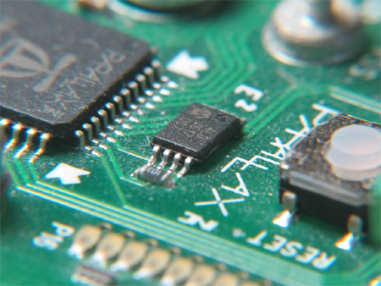](http://www.electronicsandyou.com/blog/wp-content/uploads/2013/11/smtpcb.jpg)

**There are three different approaches to solder joint cracking problems:**

1. Using a substrate with a compatible CTE;
2. Using a compliant top layer substrate; and
3. Replacing leadless ceramic packages with leaded ones.

The most widely used substrate for SMT Printed Circuit Boards, is glass epoxy. It entails no CTE compatibility problems when used for plastic surface mount packages. However, This provides the solution for commercial applications only.

The most commonly used substrate for PCBs for military applications is one with a CTE value compatible with that of the ceramic packages that has been specified. Each PCB substrate option has its own advantages and disadvantages. Designers need to be carefully balances the constraints of cost with reliability and performance needs. In addition, [solder](http://www.electronicsandyou.com/blog/cored-solder-wire-all-about-flux-cored-solder-wire.html) masks and via hole sizes should be selected carefully.

**SMD Surface Mount Electronic Components for SMT**

Santosh Das July 31, 2015   [Electronic Components](http://www.electronicsandyou.com/blog/category/electronic-components), [Electronics](http://www.electronicsandyou.com/blog/category/electronics), [SMT](http://www.electronicsandyou.com/blog/category/smt)   [34 Comments](http://www.electronicsandyou.com/blog/smd-surface-mount-electronic-components-for-smt.html#comments)

*SMD or Surface Mount Electronic Components for SMT* are no different from *through-hole components* as far as the electrical function is concerned. Because they are smaller, however, the SMCs (*surface mount components*) provide better electrical performance.

Not all components are available in surface mount for [**electronics**](http://www.electronicsandyou.com/) at this time; hence the full benefits of surface mounting on [**PCB**](http://www.electronicsandyou.com/PCB/pcb.html) are not available, ad we are essentially limited to mix-and-match surface mount assemblies. The use of through-hole components such as pin grid array for high end processors and large connectors will keep the industry in mixed assembly mode for the foreseeable future.

**Availability of Surface Mount Electronic Components**

While only a few types of conventional *DIP packages* meet all the packaging requirements, the world of surface mount packages is vastly more complex.

[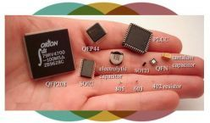](http://www.electronicsandyou.com/blog/wp-content/uploads/2013/08/Smd.jpg)

SMD (Surface Mount Device): Surface Mount Electronic Components for SMT

The package types and package and lead configurations available are numerous. In addition, the requirements of surface mount components are far more demanding. SMCs must withstand the higher soldering temperatures and must be selected, places, and soldered more carefully to achieve acceptable manufacturing yield.

There are scores of components available for some electrical requirements, causing a serious problem of component proliferation. There are good standards for some components, whereas for others standards are inadequate or nonexistent. Some electronic components are available at a discount, and others carry a premium. While *surface mount technology* has matured, it is constantly evolving as well with the introduction of new packages. The electronics industry is making progress every day in resolving the economic, technical, and standardization issues with *surface mount components. SMDs* are available as both *active and passive electronic components*.

**Passive Surface Mount Electronic Components**

The world of passive surface mounting is somewhat simpler. *Monolithic*

[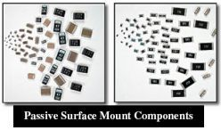](http://www.electronicsandyou.com/blog/wp-content/uploads/2013/08/Passive-Surface-Mount-Electronic-Components.jpg)

Passive Surface Mount Electronic Components

*ceramic capacitors, tantalum capacitors, and thick film resistors* form the core group of *passive SMD*. The shapes are generally rectangular and cylindrical. The mass of the components is about 10 times lower than their through-hole counterparts.

The *surface mount resistors and capacitors* come in various case sizes to meet the needs of various applications in the electronics industry. While there is a trend toward shrinking case sizes, larger case sizes are also available if capacitance requirements are large. These devices/ components come in both rectangular and tubular (*MELF: metal electrode leadless face*) shapes.

**Surface Mount Discrete Resistors**

*There are two main types of surface mount resistors*: thick film and thin film.

[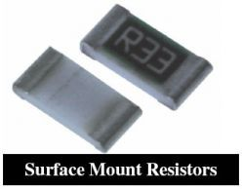](http://www.electronicsandyou.com/blog/wp-content/uploads/2013/08/Surface-Mount-Resistor.jpg)

Surface Mount Resistor

*Thick film surface mount resistors* are constructed by screening resistive film (ruthenium dioxide based paste or similar material) on a flat, high purity alumina substrate surface as opposed to depositing resistive film on a round core as in axial resistors. The resistance value is obtained by varying the composition of resistive paste before screening and laser trimming the film after screening.

In thin film resistors the resistive element on a ceramic substrate with protective coating (glass passivation) on top and solderable terminations (tin-lead) on the sides. The terminations have an adhesion layer (silver deposited as thick film paste) on the ceramic substrate, and nickel barrier underplating followed by either dipped or plated solder coating. The nickel barrier is very important in preserving the solderability of terminations because it prevents leaching (dissolution) of the silver or gold electrode during soldering. Resistors come in 1/16, 1/10, 1/8 and ¼ watt ratings in 1 ohm to 100 megaohm resistance in various sizes and various tolerance. Commonly used sizes are: 0402, 0603, 0805, 1206, and 1210. A surface mount resistor has some form of colored resistive layer with protective coating on one side and generally a white base material on the other side. Thus the outer appearance offers a simple way to distinguish between resistors and capacitors.

**Surface Mount Resistor Networks**

The surface mount resistor networks or R-packs are commonly used as

[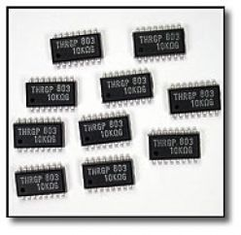](http://www.electronicsandyou.com/blog/wp-content/uploads/2013/08/Surface-Mount-Resistor-Networks.jpg)

Surface Mount Resistor Networks

replacement for series of discrete resistors. This saves real estate and placement time.

The currently available styles are based on the popular *SOIC (Small Outline Integrated Circuits*), but the body dimensions vary. They generally come in 16 to 20 pins with ½ to 2 watts power per package.

**Ceramic Capacitors for SMT**

*Surface mount capacitors* are ideal for high frequency circuit applications because it does not have any leads and can be placed underneath the package on the opposite side of the PCB. The most widely used packaging for ceramic capacitors is 8 mm tape and reel.

[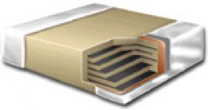](http://www.electronicsandyou.com/blog/wp-content/uploads/2013/08/Surface-Mount-Ceramic-Capacitor.jpg)

Surface Mount Ceramic Capacitor

*Surface mount capacitors* are used for both decoupling applications and for frequency control. *Multilayer monolithic ceramic capacitors* have improved volumetric efficiency. They are available in different dielectric types per EIA RS-198n, namely COG or NPO, X7R, Z5U, and Y5V.

Surface mount capacitors are highly reliable and has been used in high volumes in under-the-hood automotive applications, military equipments and aerospace applications.

**Surface Mount Tantalum Capacitors**

*For Surface Mount capacitors, the dielectric can either be ceramic or tantalum.*

[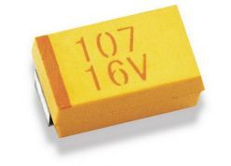](http://www.electronicsandyou.com/blog/wp-content/uploads/2013/08/Surface-Mount-Tantalum-Capacitors.jpg)

Surface Mount Tantalum Capacitors

*Surface mount tantalum capacitors* offer very high volumetric efficiency or a high capacitance-voltage product per unit volume and high reliability.

The wrap-under lead capacitors, commonly called plastic molded tantalum capacitors, have leads instead of terminations and a beveled top as a polarity indicator. There are no soldering or placement concerns when using the molded plastic tantalum capacitors. They are available in two case sizes – standard and extended range. The capacitance value for tantalum capacitors vary from 0.1 to 100 µF and from 4 to 50 V dc in different case sizes. They can also be custom made as per the requirement of the application. Tantalum capacitors are available with or without marked capacitance values in bulk, in waffle packs, and on tape and reel.

**Tubular Passive Components for SMT**

The cylindrical devices known as metal electrode leadless faces (MELFs) are

[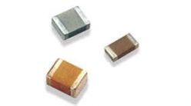](http://www.electronicsandyou.com/blog/wp-content/uploads/2013/08/SMD-Tubular-Passive-Components.jpg)

SMD Tubular Passive Components

used for resistors, jumpers, ceramic and tantalum capacitors, and diodes. They are cylindrical and have metal ends caps for soldering.

Since MELFs are cylindrical, the resistors do not have to be placed with resistive elements away from the board surface as is the case with the rectangular resistors. MELFs are less expensive. Like the conventional axial devices, MELFs are color coded for values. MELF diodes are identified as MLL 41 and MLL 34. MELF resistors are identified as 0805, 1206, 1406 and 2309.

**SMD Active Components for SMT (Leadless Ceramic Chip Carriers (LCCC), Ceramic Leaded Chip Carriers (CLCC)**

Surface mounting offers more types of active and passive packages than

[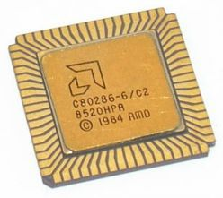](http://www.electronicsandyou.com/blog/wp-content/uploads/2013/08/Leadless-Ceramic-Chip-Carrier-LCCC.jpg)

Leadless Ceramic Chip Carrier (LCCC)

through-home mount technology.

Here are all the various categories of active surface mount component packages

1. ***Leadless Ceramic Chip Carriers (LCCC):*** As the name indicates, leadless chip carriers have no leads. Instead they have gold plated, groove-shaped terminations known as castellations that provide shorter signal paths allowing higher operating frequencies. The LCCCs can be divided into different families depending on the pitch of the package. The most common is 50 mil (1.27 mm)

[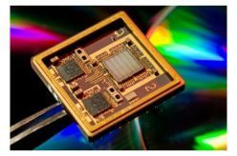](http://www.electronicsandyou.com/blog/wp-content/uploads/2013/08/Ceramic-Leaded-Chip-Carrier-CLCC.jpg)

Ceramic Leaded Chip Carrier (CLCC)

family. Others are 40, 25 and 20 mil families.

1. ***Ceramic Leaded Chip Carriers (CLCC) (Preleaded and Postleaded)***: Leaded ceramic carriers are available in both preleaded and postleaded formats. The preleaded chip carriers have copper alloy or Kovar leads that are attached by the manufacturer. In postleaded chip carriers, the user attaches the leads to the castellations of the leadless ceramic chip carriers.

When leaded ceramic packages are used, their dimensions are generally the same as in plastic leaded chip carriers.

**SMD Active Components for SMT (Plastic Packages)**

As discussed above, ceramic packages are expensive and are used primarily for military applications. Plastic SMD packages, on the other hand, are most widely used packages for nonmilitary applications, where hermiticity is not required. The ceramic packages have solder joint cracking due to CTE mismatch between the package and the substrate, but the plastic packages are also not trouble free.

***Here are all the Active SMD Components (Plastic Packages):***

**Small Outline Transistors (SOT)**

Small Outline Transistors are one of the forerunners of active devices in surface

[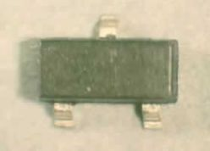](http://www.electronicsandyou.com/blog/wp-content/uploads/2013/08/Small-Outline-Transistors-SOT.jpg)

Small Outline Transistors (SOT)

mounting. They are three- and four-lead devices. The three-lead SOTs are identified as SOT 23 (EIA TO 236) and SOT 89 (EIA TO 243). The four-lead device is known as SOT 143 (EIA TO 253).

These packages are generally used for diodes and transistors. The SOT 23 and SOT 89 packages have become almost universal for surface mounting small transistors. Even as the use of high pin count complex integrated circuits is becoming widespread, the demand for various types of SOTs and SODs continue to grow.

**Small Outline Integrated Circuit (SOIC and SOP)**

The small outline integrated circuit (SOIC or SO) is basically a shrink package

[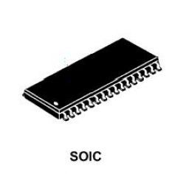](http://www.electronicsandyou.com/blog/wp-content/uploads/2013/08/Small-Outline-Integrated-Circuit-SOIC-and-SOP.jpg)

Small Outline Integrated Circuit (SOIC and SOP)

with leads on 0.050 inch centers. It is used to house larger integrated circuits than is possible in SOT packages. In some cases, SOICs are used to house multiple SOTs.

SOIC contains leads on two sides that are formed outward in what is generally called gull wing lead. SOICs need to be handled carefully to prevent lead damage. SOICs come in mainly two different body widths: 150 mil 300 mils. The body width of packages having fewer than 16 leads is 150 mil; for more than 16 leads, 300 mil widths is used. The 16 lead packages come in both body widths.

**Plastic Leaded Chip Carriers (PLCC)**

The plastic leaded chip carrier (PLCC) is a cheaper version of ceramic chipcarrier. The leads in PLCC provide the compliance needed to take up the solder joint stress and thus prevent solder joint cracking. PLCCs with large die-to-package ratios may be susceptible to package cracking due to moisture absorption. They need proper handling.

[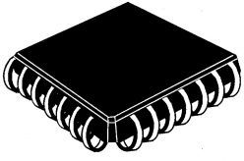](http://www.electronicsandyou.com/blog/wp-content/uploads/2013/08/Plastic-Leaded-Chip-Carriers-PLCC1.jpg)

Plastic Leaded Chip Carriers (PLCC)

**Small Outline J Packages (SOJ)**

The SOJ packages have J-bend leads like PLCC, but they have pins on only two sides. This package is a hybrid of SOIC and PLCC and combines the handling benefits of PLCC and space efficiency of SOIC. SOJs are commonly used for high density (1, 4, and 16 MB) DRAMSs.

[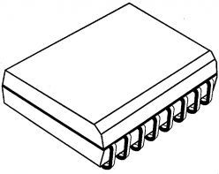](http://www.electronicsandyou.com/blog/wp-content/uploads/2013/08/Small-Outline-J-Packages-SOJ.jpg)

Small Outline J Packages (SOJ)

**Fine Pitch SMD Packages (QFP, SQFP)**

SMD packages with very fine pitch and larger number of leads are called fine pitch package. Quad flat pack (QFP) and shrink quad flat pack (SQFP) are examples of fine pitch package. Fine pitch packages have thinner leads and require a thinner land pattern design.

[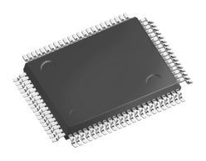](http://www.electronicsandyou.com/blog/wp-content/uploads/2013/08/Fine-Pitch-SMD-Packages-QFP-SQFP.jpg)

Fine Pitch SMD Packages (QFP, SQFP)

**Ball Grid Array (BGA)**

BGA or Ball Grid Array is an array package like PGA (pin grid array) but without the leads.

There are various types of BGAs, but the main categories are ceramic and plastic BGA. The ceramic BGAs are called CBGA (Ceramic Ball Grid Array) and

[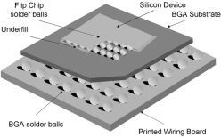](http://www.electronicsandyou.com/blog/wp-content/uploads/2013/08/Ball-Grid-Array-BGA.jpg)

Ball Grid Array (BGA)

CCGA (Ceramic Column Grid Array), and the plastic BGAs are referred to as PBGA. There is another category of BGA known as tape BGA (TBGA). The ball pitches have been standardized at 1.0, 1.27, and 1.5 mm pitch. (40,50, and 60 mil pitch). The body sizes of BGAs vary from 7 to 50 mm and their pin counts vary from 16 to 2400. Most common BGA pin counts range between 200 and 500 pins.

BGAs are very good for self alignment during reflow even if they are misplaced by 50% (CCGA and TBGA do not self align as well as PBGAs and CBGAs do). This is one reason for the higher yield with BGAs.

#### ranscript of How Motherboards Are Made:

2.Solder Paste Screen Printing  
3.SMT Assembly Line  
6. SMT Automated Reel Storage  
**How Motherboards Are Made:   
A Gigabyte Factory Tour**  
1.First steps in Motherboard Manufacturing  
Weekly production sheet identifying the motherboard models  
The DEK Infinity solder paste screen printer (left)  
Mixing and applying the solder paste to the nickel screen  
The solder paste: particles of solder suspended in flux  
Solder printed motherboards awaiting the SMT process  
Gigabyte's SMT production lines  
The FUJI pick and place SMT machines mount components on each motherboard  
Components are fed into the SMT machines from tape-like reels  
An SMT machine   
about to start   
placing components   
on a motherboard  
Each of the 16 or so heads places a different component in as little as 1/8 of a second (flash frozen in this picture)  
A motherboard part way through the SMT process. Large ICs have yet to be placed.  
Storage racks for larger SMT chips  
4.Pick and Place Chipsets  
Processors sockets are set up so that they can be picked up by the machine and placed on the PCB  
Large JUKI KE-2010L SMT chip machine. Chips are grabbed from a tray at upper left.  
Each IC is visually inspected by the machine with small light boxes to ensure no defects in solder leads or solder balls  
The IC is then carefully placed on the PCB. It takes 1-2 seconds per large IC component.  
A look down the SMT production line  
Flip side SMT line  
5.In-Circuit Testing and Visual Inspection  
The Gigabyte in-circuit   
electronic test table  
Each board is mounted on the test table  
The rack is lowered, making contact with test points on the board  
Assorted spare test rigs   
gathering dust on a shelf  
Different rigs is needed for   
every motherboard model   
Gigabyte to produce  
  
  
Automated BIOS chip and IC storage cabinet. Chips are stored in rolls to be used in SMT machines, and inventory is computer controlled.  
Special moisture free cabinets for storing expensive items  
F.E. Intel chipsets  
7. Manual Assembly (DIP) Line  
Each worker adds one or more specific components to each board  
Placing capacitors  
Piles of components are kept beside every station, here DDR sockets.  
The conveyor belt moves quite fast so workers in the assembly line need to be fast and precise  
8. Wave Soldering  
About to go into the solder wave machine.  
Note the lead weight on the chipset socket.   
This stops it floating up in the soldering iron  
  
  
Inside the soldering wave reflow machine. Note the 'waves' of liquid solder at 242 degrees Celsius  
Motherboard passing over the 'wave' of liquid solder.  
Worst job in the building? Cleaning the motherboards post-solder  
9. Buffing and Cleaning  
10. Final Assembly  
Stack of chipset heatsinks  
11. Testing Stage 2: Full Hardware Tests  
Gigabyte motherboard test center  
Pneumatic test rack clamps down onto completed motherboard to reduce worker fatigue from installing videocards and PCI Port-80 test cards all day long  
Second pneumatic arm holds connectors for the rear I/O ports  
The entire test table  
Manual testing of socket No775 on motherboard.  
Every port and connector must be tested for functionality   
Senior technicians perform more in-depth tests and repairs at a rework station  
12. Testing Stage 3: Stress test  
Temperature is set to 40 degrees Celsius in temperature controlled glass cabinet  
Every single motherboard is tested this way, all with different videocards from various manufacturers  
13. Final Motherboard Packing  
Adding stickers and accessories to the box  
Box shaping machine  
Reference board for motherboard box contents  
Sealing boxes with plastic binding  
Stacked boxes of motherboards ready for shipping around the world  
Artur Vasiliev  
Thank you for watching  
Table of Contents:  
1. First steps in Motherboard Manufacturing  
2. Solder Paste Screen Printing  
3. SMT Assembly Line  
4. Pick and Place Chipsets  
5. In-Circuit Testing and Visual Inspection  
6. SMT Automated Reel Storage  
7. Manual Assembly (DIP) Line  
8. Wave Soldering  
9. Buffing and Cleaning  
10. Final Assembly  
11. Testing Stage 2: Full Hardware Tests  
12. Testing Stage 3: Stress test  
13. Final Motherboard Packin

**Key Specifications/Special Features:**

* Machine has strong and perfect function selection
* With 8 temperature waves in temporary software
* Allows user to select right temperature wave according tosolder/unsolder request
* Intelligent temperature wave heating, can achievesolder/unsolder automatically
* 3-D adjustable lamp body, uses laser light
* Suitable for unsoldering any angle components
* PID intelligent temperature control can avoid IC damage due tofast/uninterrupted warming up
* Machine has super hot melt system, uses infrared weldingtechnology which is developed independently
* Heat is easy to pierce and distribute evenly
* Suitable for variety of computer, notebook and Sony's PlayStation BGA components
* Especially in north/south bridge chipset of computer
* Friendly human machine operation interface, LCD display towatch whole repairing process clearly
* Ergonomic design, practical and easily operated
* Good build quality but at same time lightweight and smallfootprint allows to be easily bench positioned, transported orstored

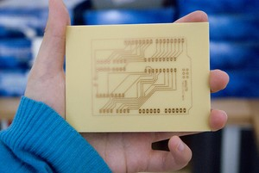

## Before we start

Fritzing's PCB View lets you design and export layout files for single-sided, DIY Printed Circuit Boards. You can also export your sketch to Gerber files, and send them to a professional PCB manufacturing service. Once you get to know Fritzing's PCB design tools and functions, creating a nice layout will become easier.

Changes in the software are constantly being made in order to improve and make this process easier for you, so please be aware that some bugs might come and go...   
  
To learn how to use Fritzing's PCB design tools, go through the following steps and guidelines:

1. [The PCB View](http://fritzing.org/learning/tutorials/designing-pcb/#anchor1)
2. [Arranging parts on the board](http://fritzing.org/learning/tutorials/designing-pcb/#anchor2)
3. [Auto-routing](http://fritzing.org/learning/tutorials/designing-pcb/#anchor3)
4. [Hand-routing](http://fritzing.org/learning/tutorials/designing-pcb/#anchor4)
5. [Guidelines for better routing](http://fritzing.org/learning/tutorials/designing-pcb/#anchor5)
6. [Editing traces](http://fritzing.org/learning/tutorials/designing-pcb/#anchor6)
7. [Export options](http://fritzing.org/learning/tutorials/designing-pcb/#anchor7)

## The PCB View

So your circuit works and also looks great in Fritzing's Breadboard View.

Let's now have a look at the PCB View. To switch to the PCB View use the Navigator or the View Switcher. While it is very easy to recognize parts in the Breadboard View, the PCB View might look a bit confusing at first glance. The reason for this is that the PCB View only shows the necessary information needed for the PCB design. This information is shown in different layers. To view or hide layers, use the View options in the menu bar. Learn more about the[PCB View layers](http://fritzing.org/learning/tutorials/pcb-view-layers/).

As an example, lets have a look first at the following circuit which was created in Breadboard View:

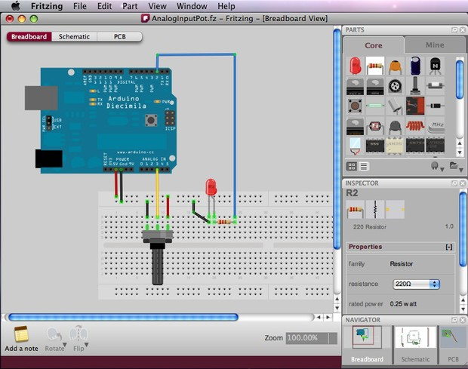

Selecting PCB View in the Navigator will show a completely different illustration of the same circuit.   
The green rectangle is the board itself, on which parts will be arranged. It is automatically placed as you open a new sketch.   
Parts are shown as footprints, including the Arduino footprint, and you can identify them by selecting or placing the cursor on them to see their labels.   
The thin connecting lines are the Rat's Nest (more about the Rat's Nest below).

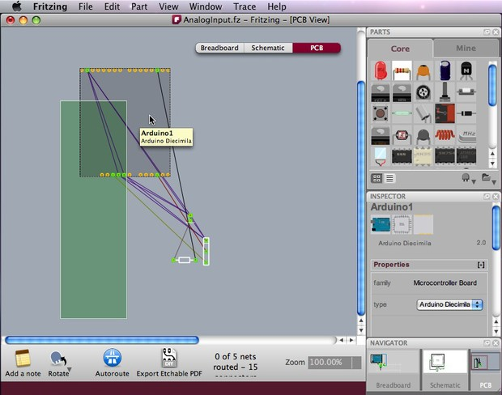

You might want to resize the board, or use an Arduino shield or a board with a custom shape. Select the board and choose/edit your prefered shape in the Inspector.

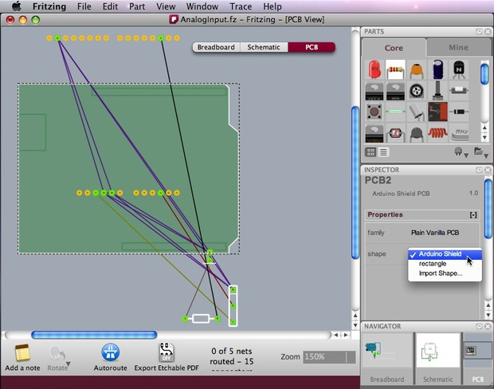

## Arranging parts on the board

The first step in designing a PCB layout is arranging the parts on the board.   
There are some very important issues to consider here, because the location of parts on the board will have a great effect on how successful the routing process will be.

Follow these guidelines:

1. Place the parts with the most connections in the middle of the board.
2. Notice that Arduino's footprint should also be positioned on the board, just like other parts (new in version 3.0).
3. Rotate and position parts, leaving enough space between them (don't forget their actual size!).
4. If the board is too small, redefine its width and height in the Inspector or alternatively resize the board by dragging its corners. [Learn how to design a PCB with a custom shape.](http://fritzing.org/pcb-custom-shape/)
5. Don't place parts too close to the edges of the board.
6. To avoid short circuits, don't place parts too close to the USB connector outline on the Arduino Shield.
7. When designing stack shields, parts' heights should also be considered.

The following screenshot shows one out of many possible part arrangements for the given circuit:

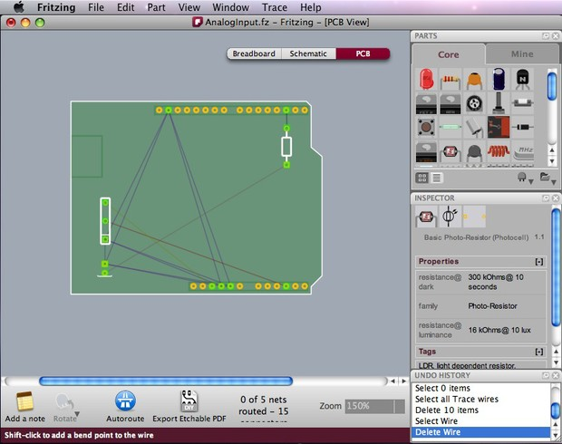

## Auto-routing

After positioning all parts on the board, be aware that parts are not really connected to each other yet. The thin connecting lines that you see (Rat's Nest Layer) only act as a guideline. We would now want Fritzing to automatically generate the connection traces between parts. Click the Auto-route function from the bottom menu bar.

If you notice that Fritzing is struggling trying to generate a connection, you can press the "Skip this Trace" button or "Cancel Auto-routing" in the bottom menu while in process.

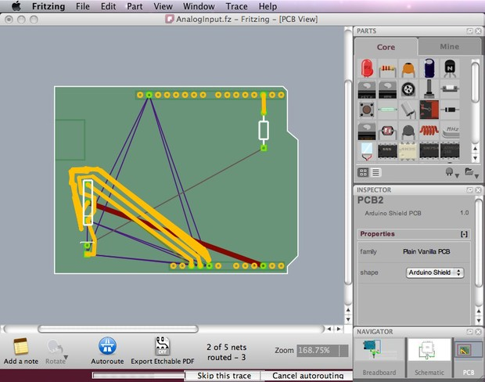

Such a problem might happen because parts were not arranged properly on the board or when there is just no possible route. You will then need to Hand-route the trace (more about hand-route below) or create a jumper. Jumpers are connections that need to be soldered with external wires. These are shown as blue connections while traces are shown as orange ones.   
In the screenshot below, two jumper wires were created after the routing between connectors failed.

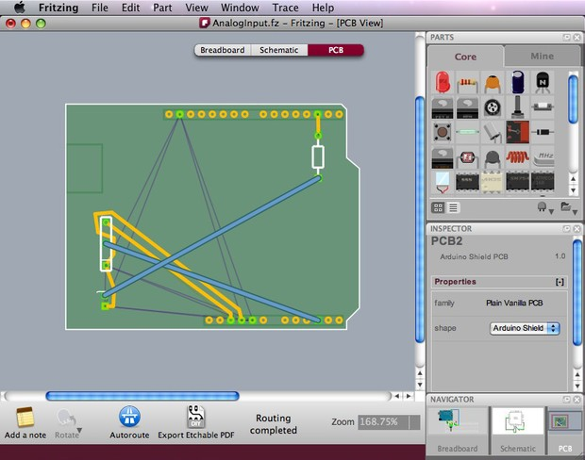

If you are happy with some of the traces and want to keep them untouched, or you know in advance that some connections need jumpers, you might want to tell Fritzing to exclude some connections in the auto-routing process. To do so, select the connections you want to exclude, choose "Don't Autoroute this trace" in the right-click menu or in the Trace menu. Only then press Auto-route. The selected traces will be left untouched while all other connections will be auto-routed. Any traces that were handrouted are automatically marked as "Don't Autoroute."

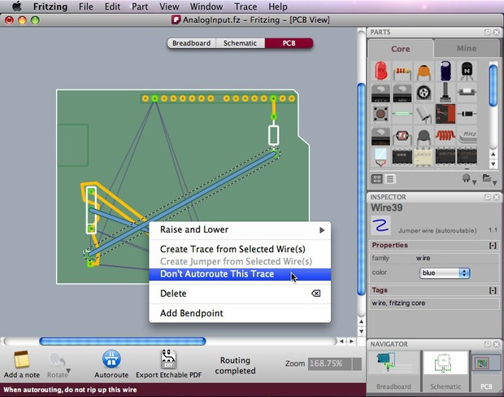

Be aware that if you moved a part after auto-routing or hand-routing, the routing traces are not corrected automatically. You will need to be cautious when moving parts and make sure you don't create any short circuits.

## Hand-routing

Use any of the following methods to hand-route traces and jumpers:

1. The safest way is to right-click a Rat's nest wire and choose "Create Trace from Selected Wire(s)" or "Create Jumper from Selected Wire(s)". This will avoid making any changes in the circuit that you built in Breadboard View.
2. Another way is to simply click a part's connector, and drag to make a connection. A trace will be created. To create a jumper, just right-click on the trace and choose "Create Jumper from Selected Wire(s)". To avoid incorrect wiring, we strongly recommend you follow the Rat's nest wire connections while using this method.

Note that while clicking and holding on a connector, all equipotential connectors are highlighted (in yellow). This shows the whole set of connections attached to this particular connection, and can really help to make hand-routing decisions. Once again, take good care not to cross wires!  
  
  
  
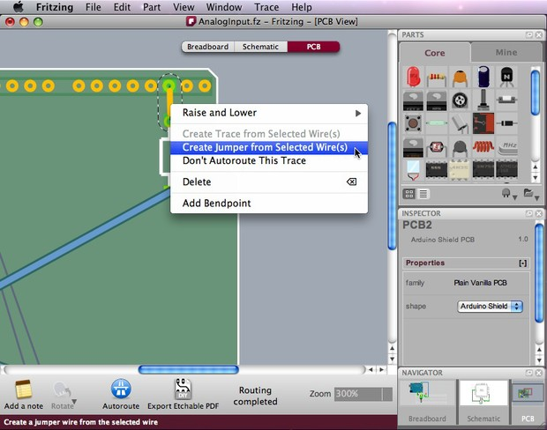

## Guidelines for better routing

For both auto- and hand-routing, follow these guidelines:

1. Place the parts with the most connections in the middle of the board.
2. Try to get short connections by moving and rotating parts.
3. Use the highlighting of equipotential connectors feature.
4. Add bend points for tidy routing and so that lines do not cross.
5. Don't forget the traces can go under parts like resistors.
6. Use jumper wires instead of watching the auto-route go crazy.

## Editing Traces

To achieve a better and nicer design, you would need to edit traces by moving, adjusting width and adding bend points. Width adjustment can be done in the Inspector. Please note that thin traces might ruin in a DIY PCB production, so keeping traces in medium thickness is safer. To create a bend points drag it simply out of a trace.

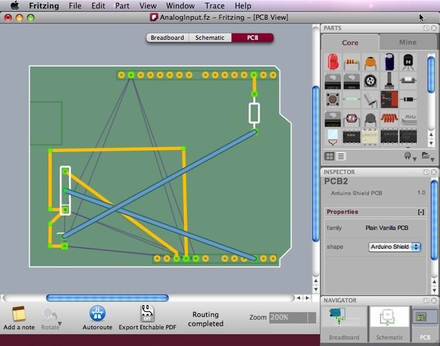

Sometimes, it would be possible to edit traces in a way that will reduce the number of  jumpers. The routing in the screenshot above was edited and a better design was achieved:

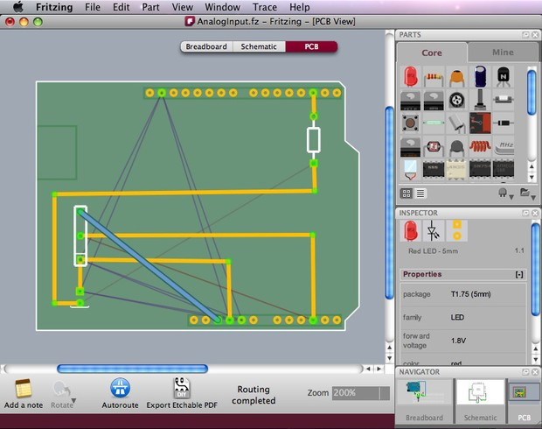

## Export Options

Fritzing features a variety of export options. When you are happy with your PCB design, you can choose to export JPG, PNG, etchable PDF and even Gerber files (for sending a professional PCB manufacturing service). The Bill of Materials option generates a list of all parts in the circuit.  
From the menu bar choose File > Export > and the desired format.

* For DIY PCB production, use the Etchable PDF option which exports only the necessary design for etching.
* When exporting Gerber files, create a folder for the gerbers, and zip. it before sending to a manufacturer.

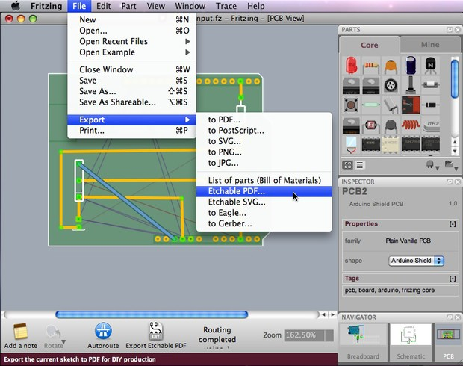

So hopefully, this tutorial helped you understand the PCB design process. Good luck and show us what you've done!

Top of Form

Bottom of Form